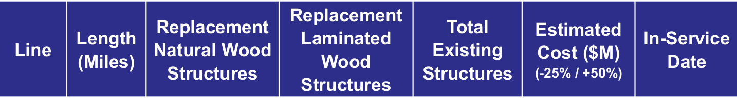
G-146 & M-108:

PEMBROKE CONSERVATION COMMISSION
FINAL MEETING MINUTES
FEBRUARY 13, 2023

“1. Special Use Permit Applications SUP-AC #23-101, SUP-WP #23-302, and SUP-SP 23-
303, Stantec Consulting Services, Inc. and Eversource Energy, owner of the utility easement
along the M108 and G146 transmission lines. The Applicant requests Special Use Permits for
utility construction in the Aquifer Conservation District, within wetlands, wetland buffers, and
potential vernal pool buffers, and within the shoreland protection district.

Matt Arsenault and Elise Ward made a presentation to the CC on the proposed project, which deals with the replacement of 65 existing wooden pole structures with significantly larger weathered-steel
structures. This is an extension of previously approved improvements of transmission facilities through the City of Concord and the Towns of Pembroke and Bow.

Roads through these easements will require significant improvement, including the permanent placement of gravel along the roadbed.

Additionally, 100’x100’ gravel work pads will be constructed at each pole location. After completion of the project 60’x30’ pads will be left at each of these sites.

The project has a planned time frame extending from early summer of 2023 through spring of 2024.’

https://www.pembroke-nh.com/sites/g/files/vyhlif4861/f/minutes/cc_mins_21323.pdf

