Access letters at: https://nhconservation.org/lib/exe/fetch.php?media=mw:writing_in_opposition_of_hotel_development_on_mt_washington.pdf

NOTE: I omitted cover letters and letters that said nothing. Also I omitted several items submitted over the past several months that were important, but not explicitly public comments on the Draft Master Plan. Many had photos that would not reproduce via cut and paste.

Jamie Sayen
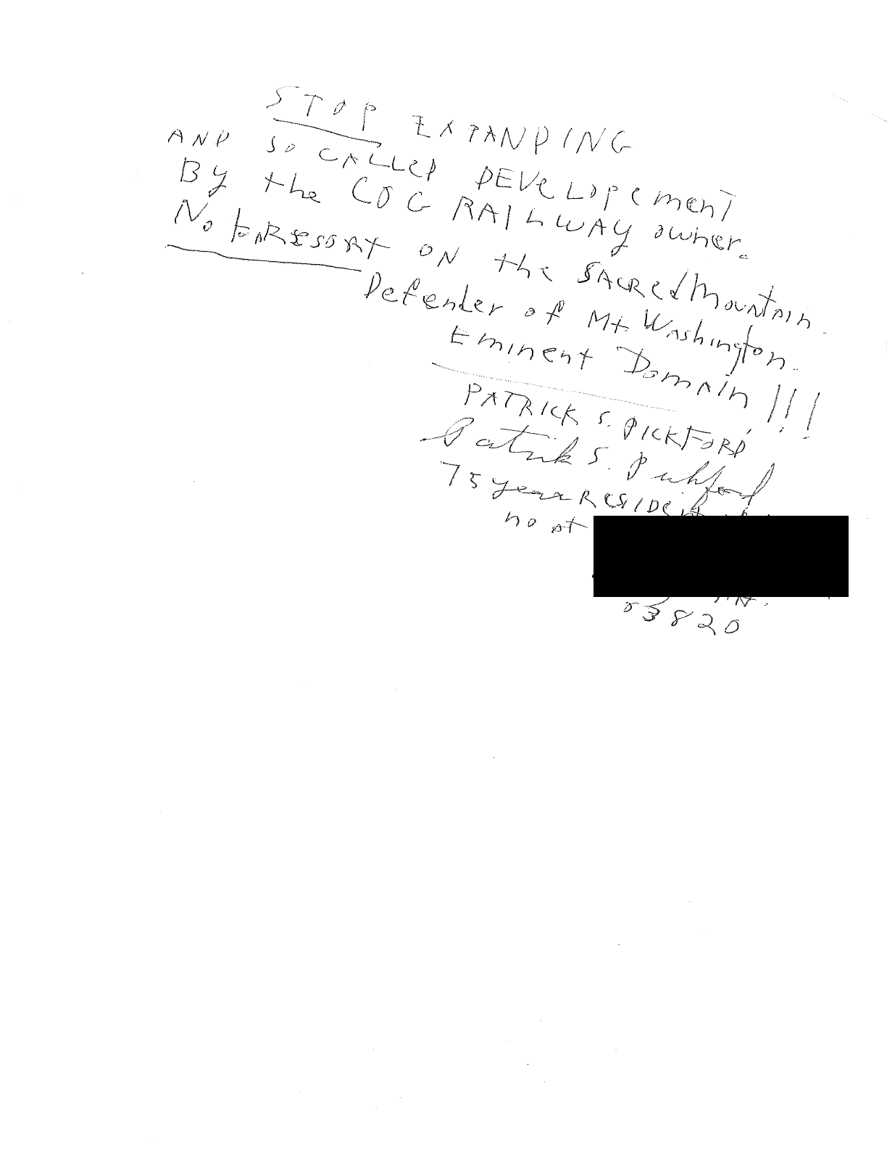
31 Aug 2022
TO: MtWashingtonComments@dncr.nh.gov
FROM: Kate Hartnett, Lancaster NH (nhkate98@gmail.com ) RE: The need to protect Mount Washington’s “Golden Eggs”
SUMMARY: I write to oppose the premature approval and construction of the Cog’s proposed Lizzie’s Station, just below the summit of Mount Washington. I understand that the proposed project is outside the 60 acre summit area that is the subject of the Master Plan. But it is inextricably linked to it, so must be seen in context of the necessity to protect this globally unique natural entity.
MY BACKGROUND: I write from my perspective as a Stage and Snow Coach driver for the Mt Washington Auto Road from 2009 to 2014. Over those five years, I made 1,400 guided round trips, in summer and winter. During those years, I asked every one of my 8,400 passengers, from every continent, how they knew of the mountain? I can confirm that Mount Washington has a compelling international reputation. I became very familiar with the complexities of operations by the many partners sharing daily access to the summit by foot, road, and cog railway. Over those five years, I also personally observed the increasing pressures on the engineered infrastructure, including food service, bathrooms, sewerage management, water supply, trash, telecommunications, parking, and trail use.
NOT A HIGH ELEVATION DISNEY WORLD: None of this is news to the Commission, or the stakeholders involved in management of Mount Washington. What is relevant is the language in the draft Master Plan:
“...The purpose of this Master Plan is to provide for this experience while enabling the success of all Summit Partners1 by ensuring that the summit of Mount Washington, featuring the Mount Washington State Park, continues to be a must-see destination for visitors to the region while also ensuring that resource values are protected. This will be achieved by: maintaining a high quality mountain experience that respects Mount Washington’s uniqueness; recognizing the mountain’s flora and fauna, its facilities, and its history; and, using a coordinated approach to address the capacities of the summit environment, buildings, sewage, waste, energy, and water systems, and transportation modes that must accommodate the full number of people expected or permitted to visit the summit each year....” (DRAFT 4, 7/5/22, page 3 on Purpose)
THE RELEVANCE OF THE GOLDEN EGGS: What comes to mind when I read about the process underway is the 2,500 year old Aesop’s fable of the goose that laid golden eggs. Attachment 1 explores that fable from a modern business management perspective. That perspective also is clearly embodied in comments from Auto Road rep Howie Wemyss:
The Auto Road submitted the following comments after the last meeting: “Before ANYTHING further is done on or near the summit, the Mount Washington Commission must see that a thorough environmental analysis is completed to gauge the current conditions on and near the summit. The purpose of this analysis is to make sure that any future expansion, development, or construction of any kind will not harm the environmental health of the summit. This may well mean that ALL entities must put their individual plans on hold in favor of the greater good of the summit of Mt. Washington. Rather than the current unfettered growth in guest numbers currently
Page | 1
happening, the numbers need to be controlled to what the current summit infrastructure can handle. This analysis will likely take several years but will be essential to the future health and success of Mt. Washington and the Mt. Washington partners.”
(from Additional Commission Concepts 19 May 2022)
GETTING IT RIGHT: Taking several years more seems prudent, given the complexity of competing demands. The update to the 1970 Master Plan began nine years ago, in late 2013. The notes from that meeting still are relevant to this discussion today, as they recognize up front that Mount Washington is “a truly unique recreational asset with a very fragile environment.” And that the core responsibilities have remained constant, at least since the 1970 Master Plan:
- Stewardship of the Summit (infrastructure, landscape)
- Visitor experience
- Carrying capacity
At the conclusion of that 2013 meeting, Commission members called for the creation of “an overarching vision for the future of the summit to guide short-and long-term decisions about improvements and infrastructure upgrades.” That has not yet happened.
RECENT PARALLEL SITUATIONS: Interestingly, similar pressures currently are being addressed at ski resorts, and in the New Hampshire outdoor recreation industry:
- TICKETS LIMITED: Vail Resorts has made the decision to limit ticket sales at 40 ski resorts across North America, including Wildcat, Attitash, Sunapee, and Crotched Mountain in New Hampshire, based on complaints about overcrowding during the 2021-2022 ski season. Vail has acted to “prioritize your on-mountain experience” by taking responsibility for stewardship of its assets. [Attachment 2]
- PROTECT NEW HAMPSHIRE’S NATURAL AND RECREATIONAL RESOURCES: Also in August, U.S. Representative Kuster convened state leaders in outdoor recreation to discuss the need to preserve and protect the year-round quality of outdoor recreation in the face of increasing demand and other pressures. [Attachment 3]
Thank you for the opportunity to provide comment. I urge the Commission and DNCR to act on the wisdom of the people and organizations of New Hampshire who so clearly understand the need to balance financial gain with protecting our Golden Eggs.
ATTACHMENTS:
(1) “True Effectiveness,” , ,
(2) “Vail resorts to limit ticket sales at ski resorts including Wildcat,” Paula Tracy, InDepthNH.org, in Conway Daily Sun, 24 Aug 2022
(3) “Kuster, outdoor leaders hold recreation powwow,” Tom Eastman, Conway Daily Sun, 24 Aug 2022
(links at NH State Parks, Commissions & Committees, Mt Washington Master Plan and Resources/Master Plan Activities web page: https://www.nhstateparks.org/about- us/commissions-committees/mt-washington-master-plan-and-resources ).
Jeff Van Fleet
President & CEO
Lighthouse Technologies, Inc.,
https://lighthousetechnologies.com/2018/07/26/examining-effectiveness-a-lesson-
from-the-golden-goose/
Page | 2
ATTACHMENT #1: TRUE EFFECTIVENESS
In Stephen Covey’s 7 Habits of Highly Successful People, he talks about building a principle- centered approach to improving your effectiveness. Here’s an excerpt:
Effectiveness Defined: The Seven Habits are habits of effectiveness. Because they are based on principles, they bring the maximum long-term beneficial results possible. They become the basis ...to effectively solve problems, maximize opportunities, and continually learn and integrate other principles in an upward spiral of growth....
And The Goose with the Golden Eggs: ...This principle can be easily understood by remembering ...Aesop’s fable of the goose and the golden egg: ...a story of a poor farmer who one day discovers in the nest of his pet goose a glittering golden egg.... Day after day, he awakens to rush to the nest and find another golden egg. He becomes fabulously wealthy; it
all seems too good to be true.
But with his increasing wealth comes greed and impatience. Unable to wait day after day for the golden eggs, the farmer decides he will kill the goose and get them all at once. But when he opens the goose, he finds it empty. There are no golden eggs—and now there is no way to
Jeff Van Fleet, President & CEO, Lighthouse Technologies, Inc.
https://lighthousetechnologies.com/2018/07/26/examining-effectiveness-a-lesson-from-
the-golden-goose/

From:
To: Subject: Date:
charlie jacobi
DNCR: Mt Washington Comments
alpine sleeper car proposal
Thursday, August 18, 2022 8:20:28 PM
I write to object to the proposed overnight accommodation sleeper cars proposed by the Cog RR. This is a bad idea on so many levels. No more such developments should be allowed in NHs alpine zone, the most fragile ecosystem in the state and the northeast. Can we not put the health of our natural world and the wild experiences still found atop New England ahead of the almighty dollar and the accommodation of ever-increasing numbers of visitors to a severely limited, fragile resource?
This rare habitat, its current overwhelming visitation, and the increasingly obvious effects of climate change demand a thoughtful, independent environmental analysis before any plan is developed. Set the draft plan aside until you know the environmental and social impacts, including the visual landscape. Better yet, toss it out because in its current form it will have undue influence on what is right for the mountain and what a large constituency of northeastern alpine enthusiasts is greatly concerned about.
Demand to reach the summit of Mount Washington will never decrease unless the population of the northeast collapses cataclysmically - and none of us want that. Do not chase demand. It's an evolutionary arms race, like a dog chasing its tail. And do not invent demand either.
In the foreword of Wilderness Ethics Laura and Guy Waterman wrote the following, and state park managers must carefully consider this for the sake of neighboring landowners, partners, and the many visitors who value wildness:
Wildness is imperceptibly eroded away. It is chipped at over time by those who want to build a hut at a quiet view spot, or locate a trail up a hitherto pathless ridge, or construct a bridge where none had been deemed necessary in the past, or are overly hasty in their use of helicopters in the mountains, or in traveling in large groups ... Each must be carefully weighed; measured against what is gained and what is lost in terms of mountain solitude and wildness. Wildness, it seems, is expendable. But once spent, like time itself, we can rarely gain it back.
If the physicists’ arrow of time in this universe is one way, on our human timescale the arrow of wildness is one way too. Wildness dies the death of a thousand cuts, it’s nibbled to death by ducks, it’s victim to the tyranny of small decisions, insert your own metaphor here, and think cumulative impact. What will be next, and when? Each little decision, or in this case, BIG decision, may be easily justified. This is the time to rely on the guidance of Aldo Leopold:
"The land ethic simply enlarges the boundaries of the community to include soils, waters, plants, and animals, or collectively: the land." Think about restraint. Think about the land. Think like a mountain.
Charlie Jacobi
Bar Harbor, Maine

From:
To: Subject: Date:
Rick Crockford
DNCR: Mt Washington Comments
Awful Idea
Tuesday, August 23, 2022 7:32:12 PM
Save the summit from greed and exploitation, please!

From:
To: Subject: Date:
Rod Parlee
DNCR: Mt Washington Comments
Balance Conservation and Visitation in Master Plan Tuesday, August 23, 2022 1:23:50 PM
Dear Commissioners, Mount Washington Commission,
The Mount Washington Summit Master Plan is an opportunity to plan for the future of this unique and cherished place. The draft Master Plan outlines a variety of potentially competing goals, such as capital improvements, protecting sensitive vegetation, enhancing visitor services, and furthering weather and science work conducted at the summit. Overall, I urge the Commission to plan for activities that uphold Mt. Washington’s critical ecological role in the northeastern alpine zone and its iconic place in the recreational and scientific fabric of our region.
The Commission should carefully consider the carrying capacity of the summit and plan for facilities that accommodate an appropriate number of visitors. Allowing for or encouraging a significant growth in the number of visitors would place an undue burden on the unique alpine ecology of this site, where sensitive plant species have already been significantly impacted by heavy use.
The Commission must plan for improving the physical accessibility of summit facilities and the visitor experience should be enhanced for all persons when considering any user fee proposals for future access.
The summit improvements should be informed by a comprehensive set of environmental studies that must be completed to understand potential impacts. A summit assessment should incorporate these environmental studies, to avoid, minimize and mitigate any potential impacts on Mt Washington’s alpine ecology.
The Master Plan must seek to manage a sustainable footprint on Mount Washington that includes achieving net zero emissions and minimizing waste, noise and light pollution, and scenic impacts of current and future operations.
Finally, the Master Plan outlines additional studies, site plans, and operational plans that will need to be developed. These plans and their implementation should be done in close coordination with the United States Forest Service and other stakeholders to ensure the greatest degree of planning across a larger, integrated landscape.
Regards, Rod Parlee
Bolton, CT 06043

NOTE: 130 OF THESE FORM LETTERS, PROBABLY GENERATED BY AMC, WERE RECEIVED

From:
To: Subject: Date:
lee warren
DNCR: Mt Washington Comments
No need to wreck one of the great treasures of New Hampshire and all of New England -- Mount Washington. Do NOT let someone build a massive resort or any hotel up there. It's too important. Build it below, look up at the mountain in all its glory.
Lee Warren
North Sandwich, NH

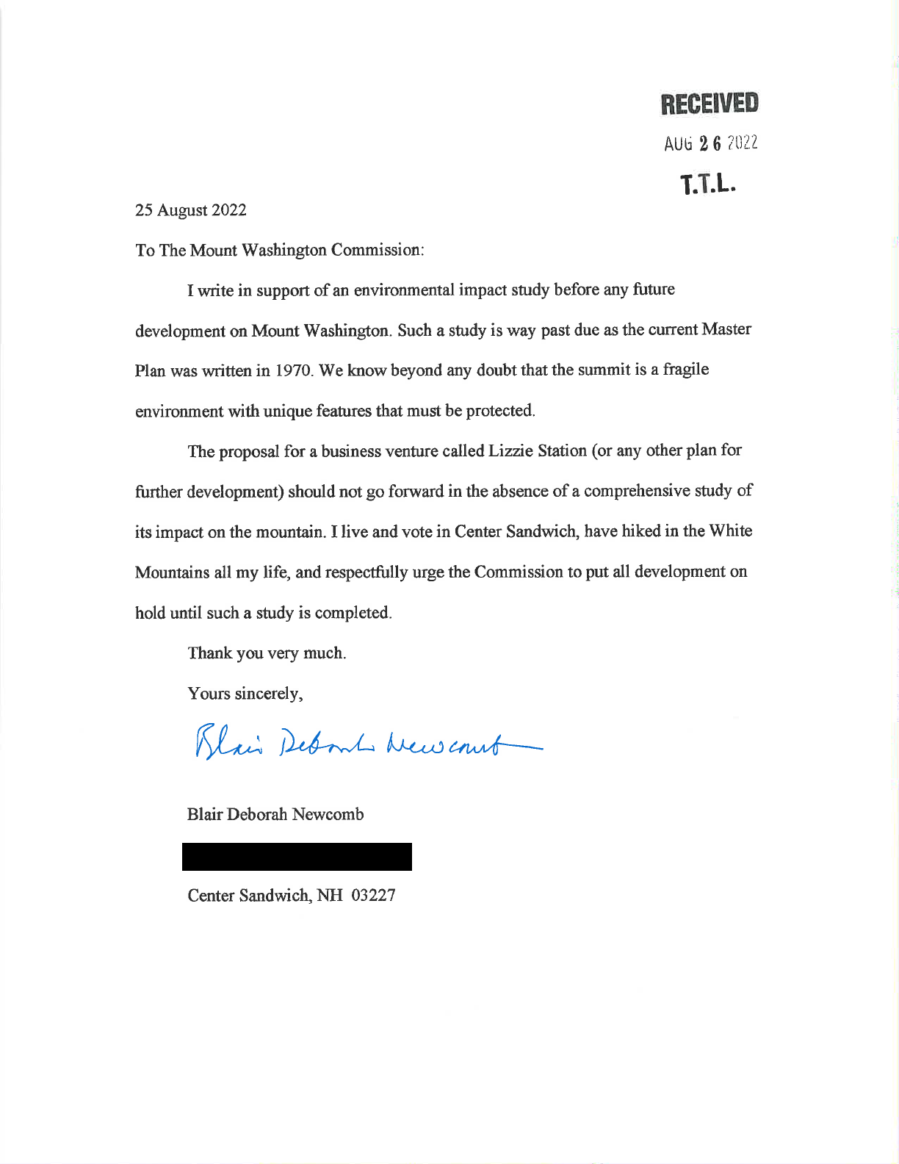

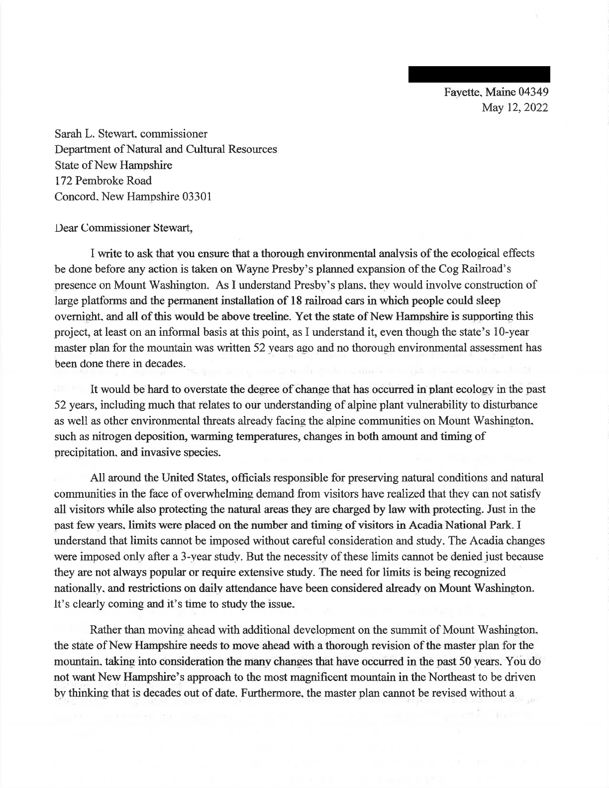
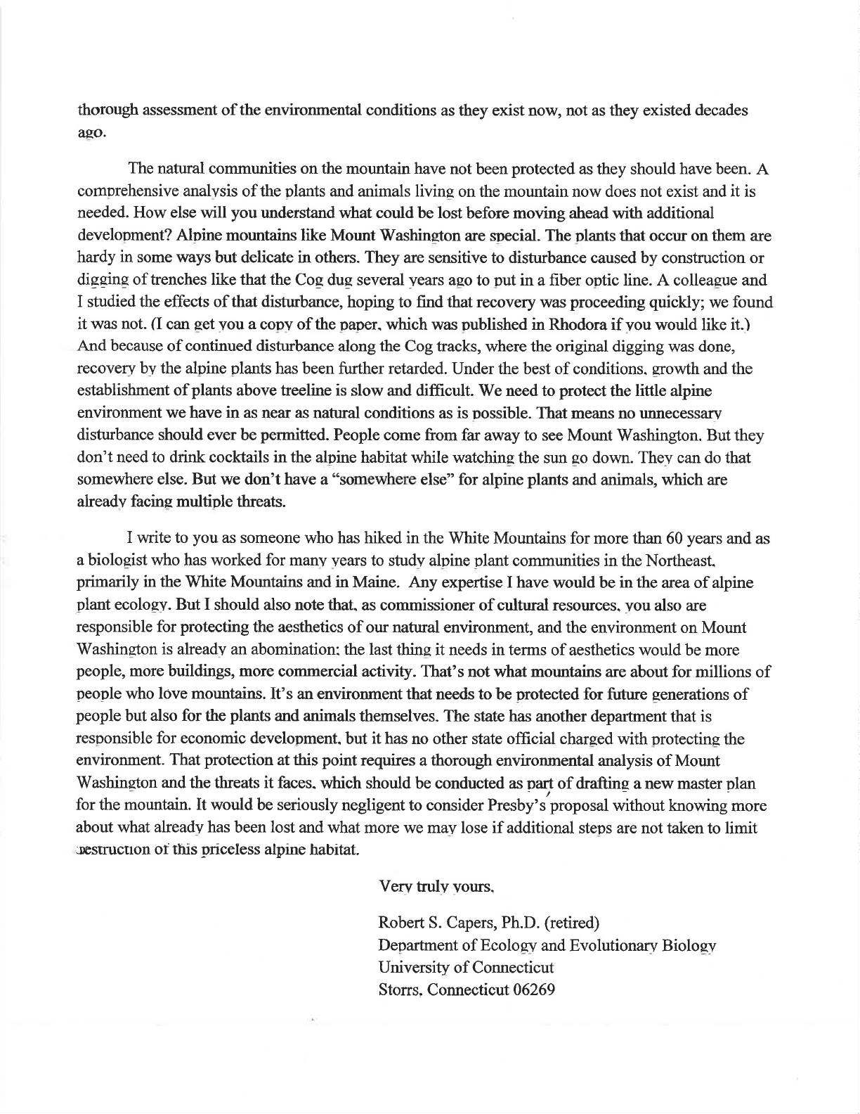
From:
To:
Cc: Subject: Date:
RICHARD EICHHORN
DNCR: Mt Washington Comments RICHARD EICHHORN;
Cog expansion
Wednesday, August 31, 2022 11:16:39 AM
Cog Railway expansion on Mt. Washington is a bad idea.
The proposed cog expansion is purely and simply, a hotel compound. Sure, it's composted of portable rail cars, and seasonal, but a hotel none the less. It will require all the infrastructure of a hotel, water, bathrooms, septic, electricity, etc.
Although the cars will be seasonal, many of the infrastructure features that go with it will not be. Imagine the impact that years of construction equipment and activity will have on the natural beauty and local environment. A few extra railway cars sound neat and clean in comparison to the actual aesthetic damage and environmental impact this project will create.
Now imagine the hotel patron, after a night of drinking, that decides to check out the view. What are the chances this person falls, gets hurt, or lost wandering away from the compound.? Now overstretched rescue personal have another rescue mission to deal with. What about the empty glass or beer bottle in their hand. What are the odds it ends up at the bottom of the Ammonoosuc Ravine?
The Cog Railway already seems to give a blind eye to the environmental impact of their activities. If you have ever walked near their property, you would be disgusted on how much scrap coal and other track debris litters the land from their activity.
Miles of track length is bordered on both sides by coal dust, which in no doubt impacts the surrounding environment. Instead of allowing them to spend millions to build more high impact infrastructure on the slopes of one of NH's finest natural features, how about they clean up the environmental disaster they have already caused.
Richard Eichhorn Hopkinton, NH

From:
To: Subject: Date:
CHARLES BRISTOL
DNCR: Mt Washington Comments
Cog Railway Hotel Proposal
Thursday, August 25, 2022 3:18:56 PM

I am writing to express my strong opposition to Wayne Presby's proposal to build a hotel along the Cog Railway right of way.
My first hike on Mount Washington was on a glorious September day in 1978. The views while scrambling up Huntington Ravine were dramatic and crossing the Alpine Garden was like being on another world. And, then, I stepped into a parking lot where my first sight was a leisure-suited gentleman getting out of a Cadillac. I ate my lunch and departed as quickly as I could.
The Mount Washington summit has only grown more crowded and commercialized since that trip. Adding a hotel a short way down-slope will only make this worse and further threaten the Mount's fragile ecology. For the sake of future generations, please reject this misguided proposal in its entirety.
Respectfully, Charlie Bristol Concord, NH

From:
To: Subject: Date:
Marshall Rowe
DNCR: Mt Washington Comments
Cog Railway Proposal
Tuesday, August 30, 2022 4:39:13 PM
Dear Commissioner,
Our family cherishes New Hampshire, especially the natural environment of the White Mountains. And we are lifelong hikers (dating back to the first climb of Mt. Chocorua in 1959) who saw our youngest son start the 4,000 footers at age 5 and finish them as a ten year old. No natural environment is more important to our state than Mt. Washington, and we strongly urge you
to deny the request of the Cog Railway Corporation to place railcars with overnight guests on the side of the mountain.
The Master Plan for the summit places primary responsibility with the NH Division of Parks and Recreation, the Mount Washington Commission, and the Summit Partners to protect the summit's unique flora and other natural resources. With our climate changing and risks to our precious resources increasing, it is more important than ever to diminish the human stress on the fragile mountain ecology. Building infrastructure to accommodate guests on the Cog above the treeline will only add to the risks and degradation of Mt. Washington's unique environment.
The Summit Master Plan states that the NH State Parks along with the Summit Partners "should aspire to minimize harm to the summit environment". Currently, NH residents and visitors have multiple ways to experience the summit, and several hundred thousand do each year. The Master Plan also says "the Auto Road and the Cog Railway should investigate ways to limit their visitors in order to contribute to the long range success of the Mt. Washington experience". Adding overnight railcars to the mountain side is not consistent with the Master Plan recommendations.
We urge you to honor the Master Plan and Mt. Washington's place in NH history and ecology, and deny the request to place railcars with overnight guests on the side of the mountain.
Respectfully,
Rachel & Marshall Rowe Hopkinton, NH 03229

August 31, 2022

MWC Master Plan Comments,
172 Pembroke Rd,
Concord, NH 03301

Re: Comment Period on Mount Washington Draft Master Plan
MtWashingtonComments@dncr.nh.gov

Dear Mount Washington Commission and Commission Staff:

Standing Trees respectfully submits the following comments regarding the Mount Washington Commission’s Draft Master Plan. Thank you in advance for your careful consideration.

Standing Trees is an incorporated nonprofit dedicated to advancing policy and legal solutions that protect and restore New England’s public lands. Our members are located throughout the New England region and beyond, including within Coös County, New Hampshire. Standing Trees seeks to hold state and federal agencies accountable for their actions that affect public lands, and to ensure that land-managers and policymakers follow the latest climate and biodiversity science. We offer the following input on Draft 4 of the Mount Washington Master Plan, dated 7/5/22.

Mount Washington is like nowhere else in the eastern United States
What we now call Mt Washington (known to the region’s indigenous people as Agiocochook) is a sky-scraping summit that has long been revered by this region’s indigenous people, and more recently, by its Euro-American settlers. The Presidential Range is like nowhere else in the eastern US – a broad-shouldered landscape perched among the clouds, where only the hardiest plants and animals survive, and where humans have always been visitors rather than residents.

In the 2005 White Mountain National Forest Management Plan, the US Forest Service, which manages the majority of the Presidential Range, notes that the Range’s “sub-alpine and alpine areas are the most interesting, unique, and sensitive biological communities in the area, and perhaps on the [White Mountain National] Forest. Many of the plants found here are at the extreme southern limit of their range. About 110 species of plants are found above timberline or in the krummholtz zone. Approximately 75 species are considered true alpine plants, as they are only found above timberline. Of these, four species native to the Presidential Range are found nowhere else in the world.” Such high praise for a treeless, alpine landscape is all the more remarkable considering that it is offered by the US Forest Service, which manages the 800,000-acre White Mountain National Forest.

Indeed, “The arctic-alpine plant diversity on [Mt Washington’s] ridges and in its gullies is greater than that found on Katahdin in Maine or any of the lower alpine summits in New Hampshire, Vermont, or New York.” In the US, the Presidential Range harbors more alpine tundra than any location east of the Mississippi River. Mount Washington supports an “old-growth ecosystem where natural disturbances continue to rein.” Unfortunately, invasive plants have colonized the summit of Mount Washington around its developed areas, notably the Sherman Adams Building and other structures around the summit.

The Draft Master Plan fails to meet the statutory requirements of the Mount Washington Commission
The Mount Washington Commission is directed to complete a Master Plan for Mount Washington every ten years. By law, the plan is required to include, at a minimum:
(a) Capital improvements to be made by the state over a 10-year period;
(b) The proposed operation of the summit by the commission including fees to be charged for the facilities operated by the commission, the method of collection of such fees, employment of personnel, franchises to be granted to concessionaires, and any other items deemed necessary to the proper operation of the summit by said commission;
(c) Promotion of the use of the summit by the public as a recreational, historic or scientific attraction;
(d) Protection of the summit as to its unique flora and other natural resources;
(e) The negotiation of public rights-of-way to the summit over private lands which benefit from the improvement of facilities on the summit;
(f) Cooperative arrangements between private interests and the commission relative to the collection of fees, joint personnel, and any like subject.

At the public hearing in Concord, NH on August 23, 2022, the above plan components were described as co-equal. This misguided idea is reinforced in Section II-Purpose, which states that “The purpose of [the Mount Washington] Master Plan is to provide for [the opportunity to observe and experience its unique environment] while enabling the success of all Summit Partners by ensuring that the summit of Mount Washington, featuring the Mount Washington State Park, continues to be a must-see destination for visitors to the region while also ensuring that resource values are protected.”

A close read of the statute makes it clear that the goals of the Master Plan are not co-equal, and that the business “success” of the “Summit Partners” is not mandated. The most important obligation of the Mount Washington Commission is “(d) Protection of the summit as to its unique flora and other natural resources.” Everything else in the Master Plan is permissible insofar as it does not degrade the “unique flora and other natural resources” of the summit. In other words, the Master Plan can direct infrastructure improvements, promote visitation, facilitate public access, and propose cooperative partnerships between Summit Partners, but only when these do not threaten the “[p]rotection of the summit as to its unique flora and other natural resources.” The final Master Plan should clarify the importance of this statutory direction to, first and foremost, protect the ecology and natural resources of the summit.

An Assessment Should be Completed Before Finalizing the Master Plan
The overriding responsibility to protect the “unique flora and other natural resources” of the summit compels the Mount Washington Commission to complete a detailed Environmental Assessment before completing the Master Plan. Without a detailed analysis of potential impacts to the biodiversity, ecology, geology and hydrology of the summit (among other criteria), there is no way for the Commission to adopt a plan that honors its most important statutory obligations.

The Master Plan should detail how the Commission will address impacts to the summit that emanate from surrounding private lands
NH Statutes, Title XIX, Public Recreation, Chapter 227-B, Mount Washington Commission, defines “Summit” as “the Mount Washington summit property owned by the state.” Impacts to state-owned property, however, may come from beyond the property boundary. The effect of impacts across land ownerships has long been recognized by the US Forest Service. The 2005 Forest Plan for the White Mountain National Forest states that “The Cog Railway, with its associated sites [sic] and sounds, has a negative effect on the Wilderness experience within the [Great Gulf] Inventoried Roadless Area.” To meet its statutory obligations and protect the public good, the Commission must guard against impacts that could lead to deterioration of the summit’s “unique flora and other natural resources,” regardless of where those impacts originate.

The Master Plan is wise to suggest that “there will always be a physical limit to the number of people on the Summit at any given time,” and that the Auto Road, Cog Railway, AMC, NH State Parks, and US Forest Service are all responsible for limiting the number of visitors and associated impacts. However, the Draft Master Plan does not go far enough to protect the summit environment.

It is well-known that the Cog Railway proposes to create a railcar hotel adjacent to the summit of Mount Washington. According to an August 16th story in the Union Leader, “Lizzie’s Station will attract yet more people to Mount Washington,” based on statements by Cog Railway owner, Wayne Presby. These new overnight visitors constitute a new use, without precedent at the summit of Mount Washington. They will undoubtedly leave the train and wander about state property at the summit. They will occupy the summit at times that the public is currently prohibited (the Auto Road closes before sunset, and no camping is allowed in or near the summit area). Will there be state staff on hand, twenty-four hours per day, to protect fragile alpine natural resources? If overnight guests get lost during a hike at dusk, as weather changes rapidly around the summit, who will pay for search and rescue?

The Commission stated at the public hearing in Concord that it has no authority or responsibility over the Lizzie’s Station project. And yet, Lizzie’s Station will certainly have an impact on state property.

Recognizing this failure of oversight by the Commission, an editorial by the Union Leader from August 28th calls for the Commission to take a more active role in evaluating and approving proposals that would impact the summit. The same editorial calls for an assessment to be completed before approving a final Master Plan. Likewise, the Lizzie’s Station proposal should not proceed before the Commission has conducted an environmental assessment, approved a master plan, and evaluated the potential impacts of the new hotel.

If the Commission does not take responsibility for the impacts of private landowners on the summit, rural county planning boards become final decisionmakers for management issues that they are ill-equipped to assess. This sort of abdication jeopardizes the public’s trust and the natural resources that the Commission is mandated to protect. The future of the summit of Mount Washington matters too much to the people of New Hampshire, not to mention the people of New England, for the Commission to remove itself from critical decisions about the future of this landscape.

Conclusion
Thank you for your consideration of these comments. Mount Washington is an irreplaceable and unequaled public resource. Draft 4 of the Master Plan does not yet take adequate care for this remarkable and iconic landmark at the top of New England. Standing Trees hopes that a future draft will correct the shortcomings of the present version.

We look forward to future opportunities to engage with the Mount Washington Commission, and we welcome your communication at any time.

Sincerely,
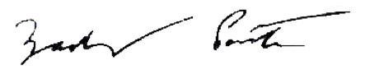

Zack Porter
Executive Director, Standing Trees
Montpelier, VT
zporter@standingtrees.org
(802) 552-0160

From:
To:
Cc: Subject: Date:
sarah doucette
DNCR: Mt Washington Comments
Roger Doucette
Comment on/ MWC Draft Masterplan/Lizzie Station Project Tuesday, August 30, 2022 2:31:37 PM
Greetings, Mt. Washington Commission Members,
We write to say we strongly oppose any alteration to the summit cone of Mt. Washington for the proposed "Lizzie Station." Any such project is an abomination and a desecration of a fragile landscape. Please reject the draft Masterplan as it now stands.
We ask that the MWC require a thorough and independent Environmental and Climate Assessment of the cone and the greater Mt. Washington area prior to the Masterplan being approved. Only then, after a full assessment, can intelligent decisions be made. Surely this is not too much to require when the proposed project will have multi-generational impacts on the mountain and all those who are drawn to its respite and recreation.
The summit is already overbuilt, overused, and overcrowded. Further expansion can only add to the existing problems. The dispersion of crowds, as suggested by the developer, is not at all a solution, but a bogus distraction from the reality of further negative impacts. Lizzie Station will draw more people to the summit and spread their damaging impact over a greater area. This high-altitude terrain, known to be very fragile, takes scores of years, sometimes centuries, to recover from even the smallest incursions. Any increase in traffic on the summit will cause further and continuing degradation of the plants and animal habitats there—and diminish the quality of the human experience. There is no restoration or remediation that can undo such damage.
It may be time for the stewards of Mt. Washington to explore limiting the usage the mountain as we see successfully demonstrated for many decades at Baxter State Park in Maine. For- profit, corporate sprawl does not belong on Mt Washington’s summit. Please exercise the privilege you have in safeguarding Mt. Washington from any variances or further development like that proposed for Lizzie Station.
Thank you for your service on the Commission and for your thoughtful consideration,
Roger and Sarah Doucette Whitefield, NH

From:
To:
Cc: Subject: Date:
Kenneth Rancourt
DNCR: Mt Washington Comments
Comment on the Mt Wash Master Plan Tuesday, August 30, 2022 9:29:53 PM
Dear Commission Members,
I would like to make comments with reference to Sections F and G, Water and Waste and Energy, Efficiency, and Sustainability, respectively. As a matter of reference, I was fortunate to be able to live on the summit for three
decades and am well aware of logistical issues there.
With respect to Waste in particular, it would be unfortunate if in the near future the Commission and State Parks Management did not fully consider partnering with the Mount Washington Cog Railway in the next phase of their operations. Assuming their Lizzie's effort proceeds, and they do install a septic line to that location, the proper design of that line could relieve
Parks from considerable expense in the future. The considerable cost of maintaining an arctic style septic system over time on the summit is not necessary. Partnering with the Cog on this issue would eliminate the need to deal with any septic issues on the summit. A modern and properly designed pumping system, with septic fields at the base not impacting any arctic vegetation and eliminating the transport of compressed solid waste from the summit would increase efficiency, reduce electrical heating costs to minimum, and be more reliable. Systems like this are known to function in mountain environments.
Given that funds are already approved for improvements to the summit waste treatment system the installation of new tanks can proceed without delay. What would change would be the method of waste disbursal. Some would say that it is too late to change the plan. I would suggest that when new information is attained (in this case the Lizzy's' effort by the Cog) any corporation or entity would take advantage of new possibilities.
Again with regard to efficiency, considering the 40,000 gallons of waste storage at the summit being installed under the current contract, the summit staff (both Observatory and State Parks Staff) would be unlikely to fill
that storage over the course of the dead of winter. Hence, there is no need of an arctic style system that requires significant electricity for heating during the winter months, no need for higher level of staffing (read higher salaries due to septic waste management certifications and related training), and limits the impact on the summit ecological environment.
I would certainly encourage those responsible to craft a comprehensive spreadsheet of costs related to the system operation over a period of ten years to understand the impact of a design change that can only decrease costs in the future and help preserve the mountain environment at the same time.
Thank you for your consideration.
Sincerely,
Kenneth L. Rancourt
Summit experience 1979 thru 2012

From:
To: Subject: Date:
John Tedeschi
DNCR: Mt Washington Comments
Comments and thoughts to Draft Master Plan Thursday, August 25, 2022 9:14:48 AM
Dear Commission member,
Thank you for the opportunity to provide comments about the use of Mt Washington and the Master Plan.
I live in Bartlett and regularly enjoy the activities on Mt Washington whether hiking, ice climbing, skiing, snow shoeing, driving visitors up the road way etc. I am a retired actuary with 40 years experience identifying and managing catastrophic risks. More recently, I a member of the Bartlet Fire and Rescue department as well as the Bartlett-Jackson Ambulance as an EMT. With this as background here are my thoughts.
The environment of the summit is beautiful, alluring, harsh and dangerous, many of the visitors that arrive by cog railroad and autoroad are not prepared for the summit. I have seen many guests (especially railroad riders) who desperately seek shelter in the Sherman Building to get out of the weather. My point is that most visitors are not prepared. Hikers are encouraged to have the 10 essentials, similarly, guests of the auto road and railroad should be encouraged to be prepared in order to reduce the dependency of the Sherman Building for shelter.
The proposal of the Cog Railway to offer hotel space is ludicrous and has many serious flaws. Here are a few.
I suspect the nightly cost of staying at the hotel will be very high, I do not think the area will attract individuals who can afford a high nightly cost. If the hotel expansion is not financially sound, who is responsible for dismantling the construction and who assumes that cost. The Commission should impose any partner within the summit area to post bonds, a good example is what happens to the hotel buildings if the Cog Railway goes into financial failure. Pleas remember that numerous multi-billion dollar firms have gone bust - Lehman Brothers in an example. The state should require each partner to have an evergreen bond established for the amount required to undo any construction previously provided. In the case of the Cog Railway proposal, they should be required to maintain a bond to dismantle and remove any construction that was part of this expansion and return area to original conditions. The bond should also be triggerable if the Cog Railway no longer properly maintains the new construction. It would be the discretion of the state to call such a bond and take over control of the proposed area.
It is easy to foresee an increase in search and rescues with overnight visitors who venture out to enjoy sunset or sunrise and get caught in the elements and are physically not prepared for the harsh environment. If the Cog Railway proposal is approved, then they should be required to staff suitable first responders to handle any search and rescue associated with their guests. The local volunteer agencies should not have to take on that additional burden and the state should not have to incur that additional cost, including helicopter resources. As a search and rescue person, I have seen the stupidity
of what goes wrong out there, whether due to intoxication, drugs, physical condition, poorly prepared, etc. The Cog Railway will make a meaningful profit with this proposal, but not necessarily assuming all the costs with running the operation.
The recent car fire at the summit should be a very realistic reminder to the commission about how challenging it is to manage a fire incident at the summit. The more buildings and attractions that are added, the risks increase. Adding over a dozen rail cars to be used by the public drastically increases fire risk. The fire risk has knock on effects of conflagration to surrounding structures and hazardous waste that would radically destroy a fragile environment.
As an add-on to the above point, the commission should also consider the evacuation impact for a large scale incident, especially during inclement weather.
The Cog Railway does not have a stellar reputation of environmental impact and has disregard for its impact on mother nature. Take a ride on the rail and notice the massive amount of debris along the railway, whether construction debris, railroad ties, etc. The smell of creosote is pungent. If they historically have not cared for mother nature, what makes the commission think that the proposed hotel area will be any better.
Medical emergencies. Similar to fire incidents, a hotel near the summit would make medical emergencies very difficult to manage. Would the Cog Railway be able to deploy a rail car in the middle of the night or could an ambulance be available to access the hotel? Would Fish and Game have jurisdiction? If so, why should state incur such costs for a private organization? The commission should consider how long it would take to have medical personnel get deployed and reach the hotel area during off hours and in inclement weather. It is incumbent on the commission to set guidelines and impose requirements that deal with life safety, regardless of the ownership of the structure at the summit. This is more important for profit making private entities, like the Cog Railway, who likely would not be incurring the costs of rescues. You could argue that an injured hiker can require massive resources and costs to extricate, but no one is financially benefiting for the hiker being out there.
Visitors to the hotel will roam around the facility which will cause more unplanned trails to be created which will destroy the landscape. Guests will more than likely do this for sunrise and sunset times to enjoy the scenery, unless this is controlled by the hotel then damage will ensue.
I do not have access to the rights granted the Cog Railway, but a railway is not a hotel. While entities like Amtrak have sleeper cars, these are not hotels. I do not see how a Railway should have hotels
I do offer a suggesting to the Cog Railway as a way to make additional money without having to make any investment and risk ruining nature high on the mountain. They can offer sunrise and sunset trips up the mountain and charge a much higher fee for this excursions. The Cog Railway staff would be responsible for managing the visitors during these special trips.
I believe that while the Cog Railway has been granted rights in the past, we should learn from our mistakes. With the benefit of today's thinking and realization that we learn from our mistakes, we should be restricting rights that might have been previously granted. Take for example the numerous confederate monuments that have been dismantled because of more modern thinking. Let's not get stuck in outdated thinking. The world is going through massive global change impact with little understanding of the future impact. Why would we think it is a good long-term benefit to have a hotel near the summit of Mt Washington, other than for profit reasons? As stewards of the summit of Mt Washington, please think of the long
term impact of the Cog Railway proposal. Please vote it down.
If any of these points require clarification, i would be happy to discuss further or expand on the topic.
Thanks you
John Tedeschi (ACAS, MAAA retired) Bartlett Fire and Rescue member 21-M-17 Bartlett Jackson Ambulance WEMT 23-x-38 Mailing address
Glen, NH 03838 Cell

From:
To: Subject: Date:
Edward Damon
DNCR: Mt Washington Comments
Comments on draft Master Plan dated 7-5-22 and the future of the Mount Washington summit Wednesday, August 31, 2022 10:52:43 AM
I am a 74 year resident of the State who grew up in North Conway, an avid hiker who has spent a lot of time on Mount Washington and the summit cone, and a regular, moderate voter.
Your draft master plan rightly recognizes the importance of minimizing the visual impact of the human-built infrastructure and maximizing protection of the natural environment at the Summit. Given the vision for the Summit expressed in the master plan, it is greatly disturbing to see so much cheerleading among certain members of the Commission for Mr. Presby’s dream project, Lizzie’s station next to the Summit. The Summit is if anything overdeveloped already and it is extremely hard to see why even more development is any solution to the Summit’s problems. In fact, the project is likely to have significant negative effects for the Summit and the experience of the many visitors who cannot afford to stay in the proposed accommodations or who don’t want to. I urge Commission members as stewards of the public interest to put politics aside and think long and hard about why Mr. Presby’s dream makes any sense at all.
Thank you for your consideration of my comments, Edward Damon
Concord, NH 03301

From:
To: Subject: Date:
Paul Doscher
DNCR: Mt Washington Comments
Comments on Mt Washington Master Plan Friday, August 26, 2022 3:21:32 PM
Thank you for the opportunity to review and comment on the draft Master Plan for Mt. Washington State Park.
As a former member of the State Parks Advisory Council, I have had a long history of engagement with the State Parks. I have been highly encouraged by the significant progress that has been made over the past decade, under the leadership of Director Phil Bryce, in addressing long standing capital and maintenance needs and creating a more efficient and effective program of park management.
The draft Mt. Washington Plan reflects a thoughtful and realistic analysis of the challenges faced at the summit and the recommendations are sound. The key will be finding the resources to implement the plan and bring the facilities up to the standard they need to achieve in order to provide for both a quality experience for visitors and to ensure the protection of the fragile alpine environment.
While it is not within the purview of the State Park plan, the matter of a proposed hotel development within the narrow strip of land owned by the Cog Railway raises some questions. Should that development take place, will the additional visitors that are provided access to the Park and surrounding National Forest lands on the summit pose new impacts to the resource and ecological protection goals of the Park? How will such a development affect the overall level of public use at the Park and will such a development result in impacts that will diminish the visitor experience?
The Master Plan clearly delineates the important improvements and repairs that are needed within the Park, but does not address the relationship of the park to the adjoining National Forest lands and those of the Auto Road and Cog. It seems to me that any plans for improvements or activities within the Park are closely related to what happens surrounding the Park, and the Plan should at least acknowledge these and suggest what criteria Parks will use to determine its reaction to proposals and plans on the surrounding land.
Sincerely,
Paul A. Doscher
Paul A. Doscher Windcrest Farm
Weare, NH 03281
From:
To: Subject: Date:
Abby Evankow
DNCR: Mt Washington Comments
comments re: Mt. Washington Master Plan Draft 4 Monday, August 22, 2022 10:03:28 PM
To the Members of the Mt Washington Commission,
I agree with the members of this Commission and the public who have already spoken of the crucial need for an environmental and climate assessment of Mt. Washington. To “minimize harm” is far too low a bar.
The Master Plan must elevate the flora & fauna to full "Summit Partner” status or else the “scientific attraction” of the summit will be its ecological decline instead of its flourishing.
I urge the commission to hire a facilitator as recommended by the Harvard Negotiation and Mediation Clinical Program and use this facilitator in the process of incorporating the environmental and climate assessment into the Master Plan. To ignore this recommendation after all the months of study and work suggests that the Master Plan will be similarly discarded.
Protect and Preserve are the first 2 priorities in the Department of Natural and Cultural Resources' mission - which is “to protect, preserve, promote and manage the State’s natural and cultural resources.” I urge this Commission to honor this mission by re-writing this draft plan to truly prioritize the protection and preservation of the fragile alpine ecology of Mt Washington State Park.
Thank you for your time.
-Abby Evankow Gorham

From:
To: Subject: Date:
Dominic Osmund
DNCR: Mt Washington Comments
Comments re: Proposed development of Lizzie Bourden Station Wednesday, August 17, 2022 4:31:56 PM
Dear Mount Washington Commission,
I am writing to you to express my strong opposition to the Cog Railway proposal to further develop and exploit the ecologically precious and vulnerable Mt. Washington summit and surrounding area.
Mt. Washington State Park is home to rare arctic tundra that provides habitat to threatened species of birds, flowers, and other wildlife. Further development of the summit area would attract more foot and auto traffic which will further pollute and damage ecosystems that, already stressed, are highly susceptible to damage.
Before any further steps are taken on the Lizzie Bourne Station proposed development, you, the Mt. Washington Commission must conduct a thorough, independent, environmental and climate assessment of the summit region and the entirety of Mt. Washington. There must be no advancement of this project without such an assessment being completed by independent ecologists and climate scientists.
I love living alongside the rare beauty of New Hampshire. The integrity and health of an area as ecologically special and critical to numerous rare and threatened species of native North Eastern wildlife. If lost, these species and ancient ecosystems will be gone forever.
They must not be sacrificed for private interests but rather protected for the benefit of all the public.
Regards,
Dominic Osmund he/him/his
Climate Electoral Fellow | 350 New Hampshire dominic@350nh.org | (815) 228-6087

From:
To:
Cc: Subject: Date:
Joe Egan
DNCR: Mt Washington Comments Terry Egan
Development Near Mount Washington Saturday, August 6, 2022 3:25:03 PM
Commissioners:
The land on and surrounding Mount Washington, regardless of whether it is privately or publicly owned, must remain as is without any additional development. Presently, the area comprising Mount Washington and the Presidential Range is a unique ecological gem that must be protected. Any type or amount of development will result in a disruption to the existing precious natural environment. There are no safeguards that can prevent this from occurring.
A strategy must also be formulated to limit the number of visitors at any specific time on the summit. Additional way stations or the expansion of parking lots will only exacerbate the overcrowded conditions that now exist.
Consider, as well, that the view of Mount Washington is a sight to behold. Any additional development will mar the visual aesthetics of Mount Washington.
Specifically, I am personally opposed to the current plans by the owner of the cog railway to build hospitality facilities below the summit. This project will ruin the visual aesthetics and it will be impossible to prevent damage to the ecology of that area. Please do not approve his request.
Best wishes, Joseph V. Egan

From:
To: Subject: Date:
Emily Benson
DNCR: Mt Washington Comments
Draft Master Plan Comments
Tuesday, August 30, 2022 11:49:52 PM
To the Members of the Mt. Washington Commission,
My name is Emily Benson and I am writing to share my opposition to the adoption of a Master Plan for the summit of Mt. Washington that is not informed by a thorough environmental and climate assessment assessment covering not only the summit region, but the entirely of Mt. Washington. I have resided in Jackson since 1991, my husband and I raising our 2 children on adventures in all seasons throughout the White Mountain National Forest, including the ridges and valleys surrounding Mt. Washington. My initial love and respect for this region developed through hiking adventures with my family as a young girl, and grew deeper during my years working in the Appalachian Mountain Club’s hut system as well as doing scientific research in the fragile alpine environment of the Mt. Washington and the Presidential Range.
An environment and climate assessment must be completed BEFORE a Master Plan is adopted. The Commission should be placing a priority on the “restoration, protection and preservation of the alpine environment of the Summit landscape and surrounding environment” BEFORE considering the services and infrastructure to be provided. Currently the quality of the environment and experience is being significantly impacted by the number of people accessing the Summit. Optimizing access to visitors over the health of the environment demonstrates that the Commission is more interested in maximizing the amount of revenue that can be generated as opposed to the protection and preservation of this unique and fragile environment in perpetuity. The Summit, as well as several other areas in the White Mountain region, are already surpassing their ability to accommodate the numbers of people that are visiting the region. Instead of increasing the infrastructure to support visitors, I believe that systems and policies should be put into place to better manage and limit the numbers of visitors to the summit so as to reduce overall environmental impacts and “maintain the quality of the mountain environment and overall experience." A thorough environmental and climate assessment must be done first in order to better inform any future plan.
Thank you for the opportunity to share my input, and I trust that the Commission will give serious consideration to all public comments that are being submitted.
Sincerely,
Emily Benson Jackson, NH

From:
To: Subject: Date:
Robert Mann
DNCR: Mt Washington Comments
Draft Master Plan - Mount Washington Commission Friday, August 26, 2022 3:55:05 PM
I am opposed to any expansion of overnight facilities at the summit or any approaches, including over, beside or in proximity to the Cog Railway corridor.
I am a 75-year old NH resident who has actively enjoyed the White Mountains since childhood. I am a long-time member of the AMC and the Society for the Protection of NH Forests. My earliest memories of visiting the White Mountains in the 1950s and 1960s were of superb natural features with a reasonable level of public access. In many ways, the State of NH has maintained a good balance between our wonderful natural resources and the need for public access to this day. I also understand the needs of the North Country and the State for tourist revenue into the future. I further understand and support the improvements proposed to summit facilities to accommodate current levels of visiting tourists. However, the proposal to add overnight accommodations associated with the Cog Railway goes beyond reason, and poses a threat to the aesthetic and natural resources that draw tourists to the North Country in the first place! Such proposals for hotels or coach sleepers is a blatant money grab intended for personal and corporate gain, and must not be allowed in association with, or proximity to, NH Parks or lands! There is plenty of space elsewhere in the North Country for hotel beds in locations which do not threaten the beauty and preservation of our public lands!
Thanks for the opportunity to comment .

From:
To: Subject: Date:
Dori Bell
DNCR: Mt Washington Comments
Draft Master Plan
Tuesday, August 23, 2022 3:17:25 PM
Dear Mount Washington Commission,
I am writing to express my opinions regarding the Draft Master Plan and the Lizzie Bourne Station.
As an avid hiker and NH resident, I am strongly opposed to the building of the Lizzie Bourne Station or any other structure to be added to Mount Washington and/or its vicinity.
As you are aware, Mount Washington is home to a unique Alpine Tundra Zone that represents less than 0 07% of the New Hampshire landscape. It is home to nearly 5 dozen rare species of plants and 2 rare species of butterflies and is so sensitive that winter camping is not permitted.
With climate change already further risking this delicate eco system, the Lizzie Bourne Station will add more people, more foot traffic, and more damage. It will take away from the natural, beautiful views of the Whites and will be a safety hazard to those visiting the Lizzie Bourne Station who are unprepared for the elements.
I am asking the commission to:
• Reject the Lizzie Bourne Station development
• Conduct a thorough, independent, environmental and climate assessment of the summit region and all of Mt Washington BEFORE starting the master plan
• Institute a complete moratorium on development until the completion of the environmental and climate assessment and master plan
• Reject the July 5, 2022 draft master plan
It is within your power to protect New Hampshire's White Mountains and 1 hope that you will listen to the people and represent our concerns fairly and thoroughly.
Sincerely, Dori Bell

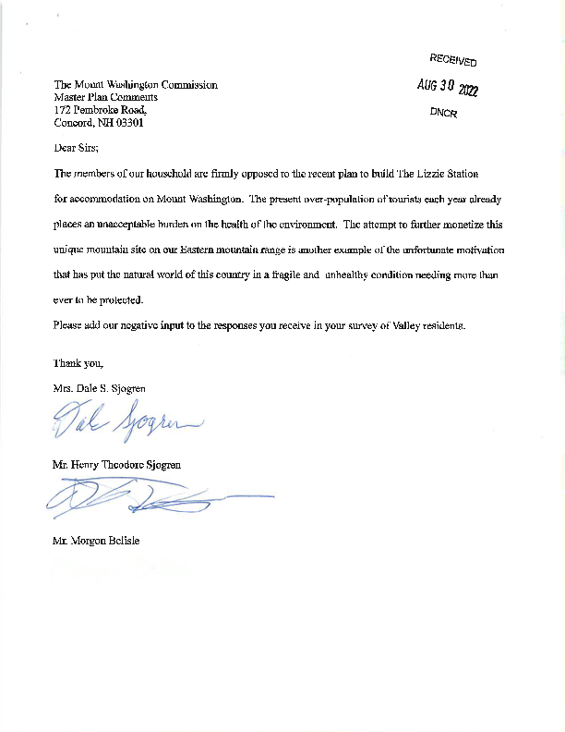

From:
To: Subject: Date:
Ray Pinard
DNCR: Mt Washington Comments
Expansion at Mount Washington Monday, August 22, 2022 11:53:12 AM
I am writing to register my opinion on the expansion plan that has been recently discussed in the media. I am not opposed to expansion of amenities at Mount Washington so long as any improvements are made without expanding the current developed footprint.
Respectfully, Ray
Raymond E. Pinard Concord, NH 03301

From:
To: Subject: Date:
DNCR: NH Parks
DNCR: Mt Washington Comments
FW: COG RAILWAYS HOTEL PROPOSAL Thursday, September 1, 2022 1:24:39 PM
From: Stamp <
Sent: Monday, August 22, 2022 1:46 PM
To: DNCR: NH Parks <nhparks@dred.nh.gov> Subject: COG RAILWAYS HOTEL PROPOSAL
TO WHOM IT MAY CONCERN,
THE IDEA OF A RAIL CAR HOTEL AT THE SUMMIT OF MT WASHINGTON IS THE MOST STUPID IDEA I’VE SEEN/HEARD IN A DECADE. GATHER THE KEY PLAYERS IN A CIRCLE ON THE LAWN OF THE STATE HOUSE AND BURN THE PLAN!
MAX STAMP

Mount Washington Commission Master Plan Public Comment on the Visitor Experience Larry Garland, May 2, 2022
The summit of Mt Washington is a unique, globally rare environment on the highest peak in Northeast.
Because of this exceptional distinction, hundreds of thousands of people visit the summit each year, in addition to the administrative, scientific, and commercial [communications] personnel that operate summit facilities. Visitors have a range of interests and expectations such that facilities and operations are challenged to provide safety, comfort, and enjoyment for everyone while protecting and preserving the rare and unique character of the environment.
To prevent undue stress and degradation of both the natural and built environments, the visitor experience must necessarily be managed within the physical constraints of the summit. To assure that visitors enjoy a positive experience, visitation should not exceed the pre-determined capacity of the summit facilities, and operational plans for limiting visitorship should be established and implemented should the need occur. Over-capacity demands should not drive unfettered expansion of infrastructure, understanding that there may be times when capacity is strained, but that the facilities are not over- built for the times that maximum capacity is not actually needed.
- Amenities should be contained within existing footprints such that the entire ‘summit circle’ does not become a sacrifice zone.
- The attraction is the natural environment; amenities should be designed and maintained so as to appear to ‘belong’ in the physical setting. Amenities should not be presented as an amusement or distraction from the native character.
- Responsible stewardship requires that there be no wandering or dispersal where it is not allowed and designated. ‘Dispersal’ of visitors should make efficient use of existing infrastructure rather than invite sprawl that creates additional impacts. All walkways should be clearly delineated with impediments to unfettered roaming.
Intrinsic to the visitor experience is appreciating the significance of this unique environment AND understanding that human activity, both physical visitation as well as climate induced, can have detrimental impacts on the health of the ecosystem. Educational information and programming should be primary aspects of the visitor experience. Preservation of the environment for future generations begins with learning about the alpine ecosystem, understanding the direct threats and impacts of climate, and accepting responsibility for protecting and stewarding the resource.
Shelter
All visitors should have access to shelter in the event of inclement or severe weather. Respecting the physical limitations of the Sherman Adams building, provisions for windbreaks or refuge in other areas with existing footprints may be appropriate. Interior, heated shelter could be pay-based as long as alternative (unheated) shelter is also available.
Restrooms
All visitors should have access to sanitary facilities. Temporary (portable) facilities or secondary outbuildings may be necessary to augment indoor restrooms in order to manage peak demand, and would serve to restrain the need for additional capital infrastructure sized for maximum load.
Food Service and Waste Management
Food service should be available in a manner appropriate to the location. How food is served is an important factor – and educational lesson – on stewarding the environment. Recyclable materials should be used if they can and are truly recycled; otherwise, the washing of dishes may be more environmentally friendly than collecting, transporting, and disposing ‘soft’ plates, bowls, and utensils that are not purposefully recycled. [Many materials are stamped with recycling emblems yet if no market exists to process them, they end up in landfills.] Messaging should encourage visitors to Carry-In Carry-Out rather than dispose their trash on the summit.
Enjoyment
Every visitor should leave the summit with a positive experience, regardless of the current weather or facilities. Through various channels of education and messaging, visitors should have the opportunity to learn about alpine ecology and understand how the health of the environment depends on how we treat it. Passive displays, interpretive signage, recorded audio tours, access to podcasts, museums, and on-site docents and naturalists can all contribute to a visitor’s appreciation and enjoyment, provided such mechanisms do not interfere with those who prefer an ‘unassisted’ experience.

From:
To: Subject: Date:
Craig Savage
DNCR: Mt Washington Comments
Hotel
Wednesday, August 24, 2022 12:50:30 PM
Hello,
I have been a resident of NH for 50 years. I love this state, the White Mountains, and Mt Washington. I have climbed the mountain at least 3 times, skied or hiked Tuckermans many times. I have taken the Cog up once.
I cannot imagine a hotel at the top of Mt Washington. It goes against every idea I have of this iconic Mt. Just because some commercial company wants to make more money? We cannot handle the crowds and traffic in NH now.
Please do not let this happen!
Sincerely,
Craig Savage Concord, NH

From:
To: Subject: Date:
Diane Starkey
DNCR: Mt Washington Comments
Hotel near summit
Wednesday, August 24, 2022 11:45:18 AM
Diane M. Starkey,
August 24, 2022 Dear Gentle Beings:
, Rochester, NH, 03867
,
The RECORD high winds and intersection of three weather wave fronts, the harshness of the isolation in the winter season for the meteorologists, the logistical challenge of building a modern, safe, weather-resistant hotel that can only be used for three seasons most safely, the need for a medical clinic to service guests and staff if it were open in winter, weatherize the hotel for fall closing, provide water and sewage storage nearby, the sheer impact this would have on the natural environment of the park and mountain, just to BUILD the hotel, staffing accommodations included, food service requirements, laundry, wi-fi, television, electricity, handicapped access, .... Need I really go on?
Profitable? Highly doubtful.
Plus the loss of any further development rights for the summit?
I really believe, not just think, you are out of your minds.
The most viable solution would be to add a hotel mid-way between the auto road entrance and the cog rail base.
Secondly; the best way to address the situation of overcrowding is to LIMIT visitors and regulate it by reservation. Yes, this would put a crimp on profits. Do you really care about the natural beauty and needs of the forest and ITS inhabitants?
A third solution would be an AMC-model facility that is manned even over the winter! It could have a much smaller footprint, be available for emergencies, have storage for medical supplies, and encourage people to really EXPERIENCE the natural glories of the mountain IN nature. It, too, would require reservations, but would be available for study groups. It could be situated between the cog railway and the auto road in approximately the same location proposed.
This AMC-style hostel would have: NO modern amenities, but handicapped accessible in all public areas; NO PARKING AREA; serviceable sewage tanks under the outhouses; propane or alcohol spirit lamps; woodstoves as a backup for propane for heat, all area-specific; a water- treatment system on solar or wind power to re-use graywater for the best conservation of water; storage of water tanks in a cellar or underground; cinderblock, well-insulated buildings; triple-pane windows; airlocks at all entrances, (except the outhouses,) and exterior removable insect screening and permanently mounted storm shutters for all windows AND doors. Water-permeable pavements or other natural treatments for roads. Arrangements to shut down in a storm for the water/electric systems for their preservation. AND yes, a sprinkler system! With baking-soda extinguishers over all cooking devices. All utensils, dishes, and drinking vessels required to be washable. No trash but the incoming food containers and sensible trash receptacles at the outhouses.
It may very well require bring-your-own food and bedding.
This would be the bare minimum, to provide accommodations for ordinary people safely ON THE
MOUNTAIN OVERNIGHT. ALSO very low chance of profit.
If the weather station does not have any of this, it is a gross neglect of their safety! I would urge their upgrade immediately!
These are most of the things that need consideration. I feel you have not yet scratched the surface – the environmental impact statement, the aesthetics of the building on the view of the mountain, the encouragement of drop-in hikers, emergency shelter needs for rescues, and many other possibilities are just a few off the top of my mind. I am certain that when you get to researching the project, you will see that the three alternatives I have presented have much more common sense. The first, my husband, Richard, thought of, is the one with a chance for profitability.
Partial copy sent to Gov. Sununu

From:
To: Subject: Date:
Robert Prohl
DNCR: Mt Washington Comments
Hotel on Mt Washington-Cog Railroad cars Wednesday, August 24, 2022 4:26:38 PM
Bad Idea-allowing additional people to spend a night or two up on the mountain; folks who are financially well off and many who have little appreciation of the beauty or the dangers of this environment is a bad idea.

From:
To: Subject: Date:
wtmthiker
DNCR: Mt Washington Comments
Hotel on Mt Washington
Wednesday, August 24, 2022 3:07:15 PM
To the committee:
I would like to add my name to the list of non-supporters for a hotel on Mt. Washington. I believe it would be dangerous and would only encourage more foolhearty people to hike unprepared and reckless. Washington has very dangerous weather during every season and I believe that a hotel on Mt. Washington might give people a false sense of security and lead to unnecessary injuries, possible deaths and many people needing to be rescued. I also believe that building and running a hotel would have a detrimental effect on the fragile environment of the mountain. I hope that you will turn down this request to protect the environment and those who risk their lives to rescue people. Thank you for considering my opinion.
Sincerely, Jackie Moulton
Concord, NH 0330q

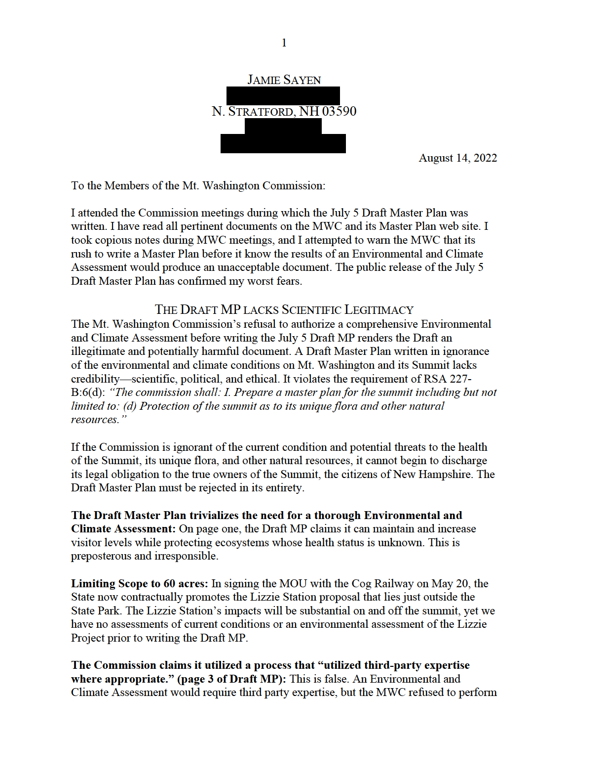
2
an Assessment prior to writing the Draft MP. The State never utilized third party expertise in monitoring the summit over the past half century.
A Scientifically-credible planning approach: The Environmental and Climate Assessment must identify and map degraded locations, sensitive areas, and current and potential climate threats. It must establish the Summit’s carrying capacity: the number of daily and annual visitors the Summit can handle without degrading any part of Mt. Washington or its summit.
Once a thorough, credible Environmental and Climate Assessment has been completed, the Planning Process can begin. The new Master Plan, informed at every step by the completed Environmental & Climate Assessment, will take steps to reduce human and carbon footprints on the summit. Necessary steps include, but are not limited to: removing the Yankee Building; clearing away debris; reducing motorized visitation below carrying capacity; and reducing hiker numbers to prevent trampling of alpine tundra. Operation of the SAB will become consistent with the Assessment findings, including Summit carrying capacity.
Section IV: Environment, Summit Assessment, and Aesthetics (page 4):
• “aspire to minimize harm:” This weak language preferences “human presence” over land health. State: “Minimize harm.” Without the Assessment, there is no way of writing a Master Plan that minimizes harm.
• “As an initial step, a Summit assessment should be completed.” Yes, BEFORE writing the MP, not after the fact.
• The Assessment must be performed by independent, third-party experts, not State Agencies. Data from Agencies should be used as a starting point to determine what additional data and research is necessary. Since MWC and DNCR have already politicized the Environmental and Climate Assessment process by refusing to perform it first, and DNCR has signed a MOU with the Cog that contractually binds the State to promote a high-impact, controversial development just outside the State Park, it is clear the State will apply political pressure to underfunded agency scientists, who, in any case, lack the full scope of expertise necessary to conduct a credible Assessment.
• “The Assessment will form a baseline for planning.” The planning for the MP was performed without this essential “baseline.” Thus, the Draft MP lacks credibility and cannot meet its mandate to protect summit health.
• “To the extent possible, NH State Parks and Summit partners should address damage and deterioration of the environment.” This is indeed a feeble commitment to protecting the summit from revenue generation... to the extent possible. Since some summit partners have a conflict of interest, they will continue to place revenue generation ahead of land health and climate mitigation.
3
At the June 10 meeting, I objected to the use of conditional verbs rather than strong verbs such as “shall address,” “shall include,” etc. I was informed this weak commitment to protection was intentional. Shame on the Commission for intentionally offering weak words instead of strong actions.
•Additional Summit structures “should be minimized while balancing on-going needs.” The State can, and must, relocate the Yankee Building off the summit. The State can, and must, reduce visitors to levels that do not degrade the mountain and summit integrity. “Balancing” is a term that means the Draft’s authors place profits ahead of land health. A responsible Master Plan would state that since we cannot alter the laws of nature, when human aspirations conflict with natural limits, we must modify human aspirations.
• “Minimize environmental damage.” The only way to achieve this is to perform the Environmental and Climate Assessment before writing a new Master Plan. Currently, the MWC has no idea whatsoever how serious the damage already is.
RSA 227-B:6(d) says “protect” the summit. Where does it authorize the State merely to “minimize the damage”? Who is the judge of what is “minimal”? Only qualified scientists can make that determination. Yet the MWC, with no members who are biologists or climate scientists, and without any monitoring over the past half century, and with no Assessment, made the determination that it was qualified to write a Master Plan in complete ignorance of current environmental and climate conditions.
• “Construction could actually promote positive environmental changes.” We need to reduce current visitor levels, not promote more construction. The idea that additional human impacts on an already degraded summit could “promote positive environmental changes” is ludicrous. This statement must be eliminated.
• “NH State Parks should account for aesthetic impacts.” This would have been good advice to DNCR before it signed the May 20 MOU with the Cog to impose a major increase in aesthetic impacts: the two 500-foot long platforms and the 18 railway cars of the Lizzie Station proposal. A major development that is one-tenth of a mile long constitutes a major aesthetic impact.
(Page 10) Perimeter Trail: We know the State is far along in drafting plans for a Summit Perimeter Trail. Where is the Environmental Assessment of such a high impact, inappropriate, major engineering project? Who will pay for the Trail? NH’s beleaguered taxpayers?
There is already too much pavement on the Summit. There are plenty of trails tourists can walk on now, including the Crawford Path and the Nelson Crag Trail. ELIMINATE any further consideration of a Summit Perimeter Trail and delete this paragraph.
(Page 11) Implementation: The Master Plan will be implemented “as soon as possible.” And yet, the State under both DRED and DNCR has failed to implement important directives from the 1970 Master Plan, especially:
4
- - Preserve summit environs
- - Identify and protect mountain flora.
The state and the MWC had half a century to act on these directives, but did not bother. The State conducted zero monitoring during the past half century. The Draft MP makes one mention of monitoring, but offers no evidence that it is serious in making this happen on a regular basis, or in providing the funding necessary to perform comprehensive, regular monitoring. We need third party experts to design an monitoring system that can be at the heart of any new planning document. How can the public trust the State to implement any environmental protections, relying on a Draft Master Plan written in ignorance of current, unmonitored conditions?
Elements of an Environmental and Climate Assessment: An independent, comprehensive Environmental and Climate Assessment must examine Mount Washington from base to summit, and not merely the 60-acre State Park. Essential elements of the Assessment include: Alpine Ecology, Climate Change, and Visitor Carrying Capacity on the summit. It must develop a rigorous, well-endowed monitoring program. The Assessment Team must be composed of independent ecologists and climate scientists, not underfunded State Agency scientists vulnerable to political pressure. The State and private interests responsible for current degradation and congestion should pay for the assessment, but have no influence over its methodology or report.
THE JULY DRAFT MASTER PLAN PROMOTES MORE VISITORS, DEVELOPMENT, CONGESTION, AND DEGRADATION OF MT. WASHINGTON AND ITS SUMMIT
Additional harmful elements of the July 5 Draft that should never appear in a Master Plan informed by an Environmental and Climate Assessment:
• (Page 2); “The Summit of Mt. Washington is iconic and emblematic of the Granite State.” The MWC might wish to reconsider the implication of this statement. The congestion, debris, waste-water permit non-compliance, and the MOU with the Cog for more development are “emblematic” of a reckless government that rules by sovereign immunity, rather than accountability to its own laws.
• (Page 2) “The Commission must try to balance conflicting goals.” When the conflicting goals are maximized revenue generation via ever-increasing motorized visitation vs. land health and mitigating climate change, such “balance” is impossible. Major environmental degradation has been inflicted for decades and increasing the causes of degradation (more motorized visitors emitting more carbon, and more development to accommodate those visitors) will result in greater degradation, not greater protection.
If there is any doubt that the State is aggressively promoting increased development, congestion, degradation, and visitation, recall that Commissioner Stewart introduced the
5
Cog’s Lizzie Station proposal on March 4 thusly: “It’s my hope that with this [new station] the state park gets a new impetus” for increased visitation.
The State cannot promote policies to increase visitation, congestion, and degradation and claim to obey the law requiring it protect the health of the summit region.
• (Page 6) Finance: “The Summit should be a model of sustainable tourism and land management.” Sadly, it is a monument to mismanagement and degradation of a sacred mountain.
• (Pages 6-7) Entrance Fee: If the State is sincere about a “fiscally-sustainable State Park,” the NH Legislature must appropriate adequate funds for its operation, and entrance fees must be charged that reflect the damage a visitor, on average, inflicts to the land, including that visitor’s carbon footprint. The entrance fee should recognize that an auto driving to the summit, and the Cog’s coal- and biodiesel-powered engines emit more hydrocarbons than a hiker. Hikers also impose substantial impacts.
• (Page 7) “To ensure smooth operations, NH State Parks should explore and consider opportunities closer to the base of the mountain to support Summit operations.”
The MWC engaged in no disciplined discussion of this important idea during its rush to produce a Draft MP. It also never seriously considered reducing motorized visitors. Currently, most motorized visitors spend an hour at the summit, waiting in line for bathrooms, consuming fast food, and purchasing cheap souvenirs. They hardly experience the wild, dangerous world of the summit.
The State should relocate the SAB off the summit. Its new building could offer a museum worthy of Mt. Washington, a mountain sacred to the Abenaki and renowned for its wildness and weather. This new building could offer visitors a virtual reality experience of ascending the mountain in all seasons. This would bring them closer to a real experience than an hour on the summit spending money in the SAB.
• (Page 7) Pikes Peak App: This paragraph is inappropriate. It is the pet project of the Cog, whose June 10 presentation on Pikes Peak extolled the potential for massive increases in visitation. Taxpayers subsidized the Pikes Peak development to the tune of millions of dollars. If the MWC and the State support taxpayer subsidized Summit degradation and congestion, the public needs to be informed.
• (Page 8) “... clarify and solidify existing property rights on the Summit.” This should clarify that existing property rights do not include:
a) The “right” to degrade ecosystem integrity or increase carbon emissions; b) The “right” to externalize the costs of degradation, pollution, or carbon
emissions onto the land, air, or public.
6
• (Page 9) Accessibility: “...ensure that the Summit is accessible and inclusive.” Section E of the 1964 Dartmouth Deed stipulated that access is “subject only to such restrictions as may be reasonably necessary to safeguard the property of the State of New Hampshire.” Protecting the ecosystem integrity of publicly owned lands that are in the care of the State is a valid limitation, essential limitation.
• (Page 9) Inclusiveness: The Draft seeks “to determine the significance of the Summit to indigenous people.” From time immemorial, the Abenaki believed it a sacrilege to climb New England’s highest mountain. Abenaki names for this wild, dangerous peak included Maji Neowaska, where a demon, or bad spirit, was supposed to dwell on the highest peak. “Inclusiveness” begins with respecting indigenous values and traditions.
• (Page 10) Yankee Building: Replacing the Yankee Building could cost in the vicinity of $15 million. The broadcasting services should be relocated off the Summit. TownSquare Media, owner of the broadcasting rights, opposes relocation because it would lose many grandfathered rights. What are these grandfathered privileges? Why should a for-profit “partner” receive special treatment that few, if any other, broadcasters enjoy?
• (Page 10) Water and Waste: The Summit’s overtaxed waste water treatment plant is a high maintenance operation. The current sewer system has been out of compliance with its permit for years. The Draft notes that it will be upgraded and its capacity increased by 50 percent. The Summit is a very small space. The solution to acute overcrowding on the finite Summit is to reduce summit visitation levels to below the Summit’s carrying capacity, not to intensify Summit congestion and expand sewage treatment facilities. Currently, the summit’s carrying capacity is unknown, but it could be established by a credible Environmental and Climate Assessment(E&CA).
Congestion creates waste water problems. The sensible solution—reduce the number of daily and annual visitors—would diminish the Cog’s and State’s revenue flows. Phil Bryce told the MWC on April 22, 2022 that “concessions and retail” are the major revenue sources for “upgrading” the Park: “We are dependent on our visitors for our well-being.”1 It appears that the State promotes more congestion to finance the Department of Parks and Recreation.
• (Page 11) Energy Efficiency and Sustainability: Reducing carbon emissions requires maximum efficiency, but it also requires substantial reductions in visitation and other carbon-emitting activities. The Draft MP, by refusing to discuss reducing current visitor levels, is proposing policies that will expand energy generation. Even if the new system is less wasteful, it fails to reduce summit-related carbon emissions.
THE COMPOSITION OF THE MWC AND ITS PROCESS 1 Jamie Sayen, “Notes of April 22, 2022 Mount Washington Commission Meeting.”
7
• (Page 2) Composition of the Mt. Washington Commission and Conflict of Interest: Currently the seats of two of the three public representatives on the MWC are vacant. The land itself has no representation. The July 5 Draft exposes the conflicts of interest of some public and private members. We need an independent MWC that represents the public interest in preserving the ecosystem integrity of Mt. Washington, not a Commission that is dominated by vested public and private interests.
• (Page 3) Process: This section is dishonest. It comes from the Harvard Report’s critique of the weaknesses of the MWC process. And now, a few months later, the MWC claims these weaknesses as accomplished virtues. The July 5 Draft shows no evidence of trust-building. Indeed, the State’s veto of performing the Environmental and Climate Assessment before writing the Draft exposes a lack of respect and trust.
• (Page 8) Recusal: This would not be necessary if the Commission were not afflicted by conflict of interest.
• (Page 11): Conclusion: “The Master Plan fulfills the Commission’s responsibilities under RSA 227-B:6.” This is a false statement because the MWC has refused to fulfill RSA 227-B:6(d) to protect the health of the summit.
Concluding Comment: The Mt. Washington Commission has an opportunity to rise to the challenge of history and climate change. To do so, it must be guided in all deliberations and actions, including the commissioning of the Environmental and Climate Assessment and subsequent Master Plan, by acknowledging that human aspirations are circumscribed by natural limits. Continued refusal to modify human behaviors that degrade Mt Washington and its Summit will accelerate the processes that are driving the alpine tundra off Mt. Washington.
Future generations expect more worthy behavior from the Commission and the State. Sincerely,
Jamie Sayen

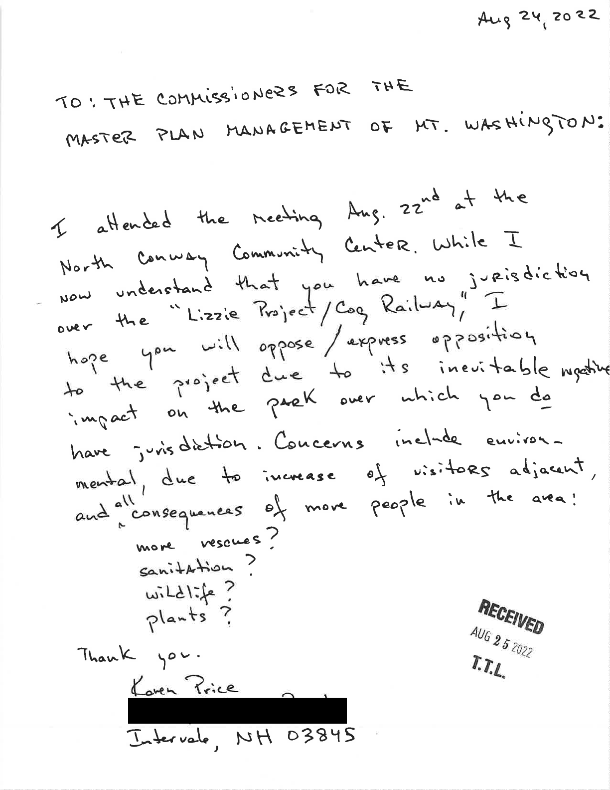

From:
To: Subject: Date:
Gretchen
DNCR: Mt Washington Comments
Lizzie Bourne Railroad Hotel proposal Wednesday, August 31, 2022 3:20:34 PM
I am writing to express my opposition to the proposed hotel development on Mt Washington.
This proposal is offensive on so many levels. The most compelling issue is environmental. Mt Washington has a unique landscape, comprised of numerous ecological zones. The alpine zone is fragile and slow to recover from disruption. I believe that there are rare and endangered plants and even one that is not found anywhere else in the world. I understand that the same is true for a specific bird found on Mt Washington. It is said that Mt Washington is the “most topographically prominent mountain east of the Mississippi River”. I understand that there are 13 square miles of alpine tundra east of the Mississippi, with Mt Washington being home to the largest and most significant tract. All interesting features, but most importantly is that the Mountain is already heavily used and environmentally compromised by that use. To think of adding 18 Pullman cars, septic “system” from the hotel to the bottom of the railway, transporting people and goods to and from the hotel, etc. and all the disruption that would come from the construction and occupancy of such a business, it’s crazy.
We see new examples of global warming on a daily basis. Further destruction of the environment will continue this trend. There is no way to justify such a project, except for the almighty dollar. There is also no need to have accommodations at the top of Mt Washington!!
I think it’s reasonable, responsible and fair for citizens to demand that a proper Environmental and Climate Assessment be done of Mt Washington and it’s summit, before considering any application from the Cog and the State.
Thank you for your time. Gretchen Hesler Franconia, NH

From:
To: Subject: Date:
Gary Newfield
DNCR: Mt Washington Comments
Lizzie Bourne Station Development Wednesday, August 31, 2022 4:04:38 PM
To whom it may concern,
I am writing to inform you of my opposition to the development of the Lizzie Bourne Station below the summit area of Mount Washington for the following reasons:
1. BEFORE any new development occurs in and around Mt Washington a complete and thorough independent environmental and climate assessment needs to be performed of the summit region. As there are only 13 acres of alpine tundra east of the Mississippi, before any new development occurs this environmental review must be completed to guide future decisions and those decisions impacts upon alpine flora and fauna.
2. I feel the acceptance of the draft master plan on 7/5/2022 should be rejected! Environmental and climate assessments must be completed BEFORE a new master plan is developed for the summit, and these assessments should be used to guide the master plan process. It is my understanding the current master plan has not been fully updated since 1970. Much has occurred since that time. Visitation and use of the summit has exploded with subsequent substantial impacts, we are now experiencing the effects of the burning of fossil fuels and the warming of our planet. Automobiles, the cog and even hikers have a carbon footprint that is affecting and will continue to affect the alpine ecosystem. Also, the current master plan does not address these issues adequately nor does it address the states obligation to maintain the ecological integrity of Mount Washington.
3. Constructing 18 new structures above tree line to reduce congestion on the summit does not solve the problem of congestion. It smacks of the old corporate adage "The solution to pollution is dilution". As with any ecosystem, Mount Washington has a carrying capacity for human impact. As much as it may be painful to say, I am in favor of limiting the number of individuals visiting the summit each day. Having hiked Mt Washington many times in the 1980's to late 1990's I never encountered the numbers of visitors as I have in the last 15-20 years. I understand it will be difficult to limit hikers as there are many routes accessing Mt Washington but I do no feel this problem is insurmountable.
4. As recent news has indicated the Mount Washington Committee is dysfunctional and needs to be restructured. A new independent
commission needs to be organized to make decisions about the summit and it's environs. Mount Washington is unique in so many ways that neither for profit entities, nor state agencies subject to political influence should be making short term decisions that will affect future generations and the ecological integrity of the summit area.
5. I repeat-I am opposed to the construction of the Lizzie Bourne Station. Mt Washington is unlike many other mountains in the region and even the country. The planet has changed significantly since Joe Dodge first proposed a weather observatory on the summit. World population has exploded, global warming is impacting huge areas of the planet including Mt Washington, the arctic is burning, Europe is experiencing unprecedented heat waves, Pakistan is under water, and I could go on. More development is not the solution to what is ailing the summit. We need to admit the summit and surrounding areas have limits and agree to what those limits should be so future generations can enjoy the area as we now know it.
Sincerely, Gary Newfield

From:
To: Subject: Date:
Ann Metcalf
DNCR: Mt Washington Comments
Lizzie Bourne Station Proposal - OPPOSED Wednesday, August 31, 2022 4:31:49 PM
To whom it may concern
I'm writing to voice strenuous opposition to the proposed development of the Lizzie Bourne Station.
There should be no actions taken to move forward on that specific project, or any other similarly disruptive development until the MWC has duly considered an Environmental and Climate Assessment of the Summit Region, conducted by a qualified, independent and impartial entity. The assessment should reflect that particular consideration is given to the unique and delicate ecosystem found at the summit of Mount Washington.
Mount Washington is already seeing far more human activity than it can support. Rather than encouraging additional and more impactful human use, measures should be taken to reduce human visitation.
Just because it's there, doesn't mean everyone gets to clamber around on it, all the time without regard for the very qualities that make the summit of Mt. Washington so special.
Thank you for your consideration. A Metcalf

From:
To: Subject: Date:
Cody Auterio
DNCR: Mt Washington Comments
Lizzie Bourne Station
Tuesday, August 23, 2022 3:42:19 PM
Mount Washington Commission,
I am writing to express my opinions regarding the Draft Master Plan and the Lizzie Bourne Station.
As an avid hiker and NH resident, I am strongly opposed to the building of the Lizzie Bourne Station or any other structure to be added to Mount Washington and/or its vicinity.
As you are aware, Mount Washington is home to a unique Alpine Tundra Zone that represents less than 0.07% of the New Hampshire landscape. It is also home to nearly 5 dozen rare species of plants and 2 rare species of butterflies and is so sensitive that winter camping is not permitted.
With climate change already further risking this delicate eco system, the Lizzie Bourne Station will add more people, more foot traffic, and more damage. It will take away from the natural, beautiful views of the Whites and will be a safety hazard to those visiting the Lizzie Bourne Station who are unprepared for the elements.
I am asking the commission to:
• Reject the Lizzie Bourne Station development
• Conduct a thorough, independent, environmental and climate assessment of the summit region and all of Mt Washington BEFORE starting the master plan
• Institute a complete moratorium on development until the completion of the environmental and climate assessment and master plan
• Reject the July 5, 2022 draft master plan
It is within your power to protect New Hampshire's White Mountains and I hope that you will listen to the people and represent our concerns fairly and thoroughly.
Sincerely, Cody Auterio

From:
To: Subject: Date:
Fred Bieber
DNCR: Mt Washington Comments
Lizzie’s Station Proposal
Tuesday, July 19, 2022 1:50:00 PM
To Whom it May Concern,
I have seen no reference to environmental concerns in any of the documents I’ve read regarding the Lizzie’s station proposal. While a part of me would like to see the cog rail and auto road go away completely, I am willing to accept the historical nature of these features and their ability to bring visitors to the alpine zone that might not be able to get there under their own power. I would however at least like to see the Cog Rail have a plan to become a net zero carbon operation in exchange for being able to expand their operations. If the plan is granted without a net zero requirement aren’t we supporting new assets which are intended to be paid back with the current diesel infrastructure? The track easement is still littered with coal debris and currently spews diesel exhaust with its PM 2.5 particulates into the alpine zone. How long do we intend to allow this to continue into our planets precarious future. I find it ironic that we intend to expand carbon polluting infrastructure in the shadow of a weather and climate scientific observatory.
Regards, Fred Bieber

8/17/2022
We are opposed to the Lizzie Bourne Station Proposed Development. Any development above timber line on Mt. Washington would have a disastrous environmental impact on this fragile and special area. By entertaining such a proposal, the State of New Hampshire is saying that making money is more important than saving our resources. It is not possible to undertake development, change one’s mind and then try to revert back to how things were originally. It would be lost forever. The committee must reject the July 5, 2022 Draft Master Plan in its entirety and demand that no MWC Master Plan be written before a credible Environmental and Climate Assessment has been completed. New Hampshire has conducted zero monitoring of the ecological impacts of the growing congestion on the summit in over half a century.
An independent, comprehensive Environmental and Climate Assessment must examine Mount Washington from base to summit, and not merely the 60-acre State Park. There must be a complete moratorium on any future expansion, development or construction of any kind until the completion of the Assessment and the subsequent Master Plan. Included in findings should be a realistic strategy to limit the number of people who are being lured to visit the summit, whether on foot, by car, train or parachuting in.
Nancy and Will DeCourcey Jefferson, NH
From:
To: Subject: Date:
andrew sharpservicesinc.biz
DNCR: Mt Washington Comments
Lizzie Station
Monday, August 22, 2022 1:20:02 PM
Could there be any more callous decision then to build an accommodation building on the side of Mt Washington?, I don't believe so,
Anyone who approves such an idea must not understand the absolute beauty and uniqueness of this wonderful place, are there no other choices for storage of Pullman Cars?, has everyone lost the understanding of what this place is all about?, it's not about tourism or making money, these areas of our state must be preserved as they are for future generations, what's next a Mcdonalds or Burger King on the alpine tundra?
Lets get it together Sen Bradley and stop this before it gets out of hand, have you seen how the rest of our country has turned into one strip mall after another, please stop the encroachment of steel and concrete on Mt Washington.
Andrew J Fraser Ossipee, NH

From:
To: Subject: Date:
MJ
DNCR: Mt Washington Comments
LIZZIE STATION
Tuesday, August 30, 2022 1:30:23 PM
PLease think of the future of our fragile above treeline environment before this abomination is allowed and sadly welcomed. The summit area is already a not nice place except for tourism and their dollars. It is wrong and greedy.

From:
To: Subject: Date:
Dear MWC,
Please establish a moratorium on new development and launch an independent, comprehensive environmental and climate assessment, before writing the new plan. It is essential for the safety and long term future of this sacred mountain. Projects like the Lizzie Station Project threaten what we have left.
Jim Contois
Member, Claremont Conservation Commission Member, Claremont City Council

From:
To:
Cc: Subject: Date:
RogerShamel
DNCR: Mt Washington Comments Susan Shamel
Master Plan Comment
Friday, August 19, 2022 1:27:49 PM
Dear Commissioners,
Thank you for accepting public comments. It's much appreciated.
We agree with those who say that the new Mt. Washington Master Plan should be based on a thorough, independent, Environmental and Climate Assessment.
Yes, it's great to have people experience the summit, but modern technology offers the opportunity for the State, and/or the Cog Railway Company to create a 360-degree audio-visual experience at the Cog's base station that could be almost as awesome, but with a very small carbon footprint, and a fraction of the environmental impact.
Very truly yours,
Roger & Susan Shamel East Washington Rd Hillsborough, NH

To - The Mount Washington Commission
Thank you for allowing public discourse to help guide the decision making process evaluating the proposed Lizzie Bourne Station. I have been a resident of the North Country since 1971, have worked on the mountain as the first winter caretaker in Tuckerman Ravine, experienced the second highest wind ever recorded while caretaking there and continue to care about our mountain. It seems essential that the commission require an independent environmental and climate assessment before even considering any proposal to construct the proposed Lizzie Bourne Station. The 500 foot proximity to the summit, the fragile alpine zone, impacts to several endangered species, weather and overloading of an already stressed infrastructure should dictate an impartial assessment.
It seems paradoxical that the proposed station should be named after Lizzie Bourne, the first person to succumb to the elements in 1849. The most recent fatality #160, died of a heart attack this past week. Attracting additional guests to the mountain seems problematic at best. There have been a couple of fatalities near the summit this year alone in addition to several other rescues. Having an influx of up to 70 people per night staying in sleeper cars, wandering the summit in sneakers and street shoes seems like a recipe to burden the already overtasked search and rescue community.
The Appalachian Mountain Club’s last hut, Mizpah, was added to their system in 1964. The organization withdrew a proposal to construct a new hut near Ethan Pond several years ago for impact concerns. The proposed site was at a much lower elevation than what is being considered for this cog venture. The wind that I encountered while I was caretaking in Tuckerman Ravine tore the roof off a section of Lakes of the Clouds Hut. The 181 MPH wind came up Oaks Gulf and pressurized the hut from the inside. When it subsided it forced the roof to lift and the continuing gale blew the leading edge into Ammonoosuc Ravine. The proximity of what I will call the Presby Trailer Park to the summit, should give anyone in their rightful mind some pause. The kind of wind I experienced when I was in Tuckerman Ravine would surely topple a rail car.
When I think about the economics of this, I have to question the common sense of what is being proposed. It should be recognized that the motivation for this is greed and profit mongering. The summit is already overbuilt. What is the suggested cost of staying overnight in a sleeper car? Who will be responsible for the many searches and rescues. NH fish and Game are normally tasked with that responsibility but it seems that the Cog railway should contribute up to $25 / guest as a hike safe fee. If the economics don’t work who will be responsible for restoring the site to its former alpine condition if that is even possible. So many questions that the commission should take into account. The cost of an environmental - climate assessment should be borne by the Cog Railway and incorporated into their own cost benefit analysis. I have to question what the cost for an overnight stay would be when 70 guests can be accommodated / night, maybe 120 nights / year. What are they thinking? The commission should know the answers to these and many more questions. Seems more like whimsy than
anything realistic. From my perspective this proposal shouldn’t even be considered. It is a complete waste of time and an exercise in futility. Thank you for considering my comments.
Larry Jenkins Randolph NH.

From:
To: Subject: Date:
Julia Slaughter
DNCR: Mt Washington Comments
Master Plan Comment Submission: Mt Washington Commission Friday, August 19, 2022 7:57:51 PM
I am opposed to the Lizzie Bourne Station proposed development, and I demand that the MWC conduct a thorough, independent, Environmental and Climate Assessment of the Summit Region and the entirety of Mt. Washington. I also demand that there be a complete moratorium on any future expansion, development, or construction of any kind until the completion of the Assessment and the subsequent Master Plan. This is for the preservation of not only a beloved monument of the Northeast, but of a delicate ecological region
we cannot disregard without dire consequences.
I reject the July 5, 2022 Draft Master Plan as it stands and and demand that no MWC Master Plan be written before a credible Environmental and Climate Assessment has been completed. Thank you for your time.
Julia G Slaughter
Middlebury, CT
Mt Washington lover, hiker and naturalist

Mount Washington Commission Comments on Master Plan Draft of 7-5-2022
The last approved Master Plan for the summit of Mount Washington is dated 1970. In the ensuing decades, most of the recommendations established then have been carried out. Speaking as someone who recalls conditions on the mountain and in what is today Mount Washington State Park at that time, the transformation has been remarkable, and some recognition could be given in a new Master Plan for the vast improvement in conditions on and around the summit. Not only have the summit buildings and water, sewage disposal and electrical infrastructure been transformed in accordance with the 1970 plan, but both the Auto Road and the Cog Railway have improved their operations substantially. The Cog Railway in particular deserves much credit for its years-long cleanup of its right of way from base to summit and for its fuel conversion that has had a substantial impact on air quality in the region. The hiking trails that lead to the summit, while heavily used, are generally in better condition that in the 1970s following extensive hardening in that and succeeding decades.
Although the Mount Washington summit has been intensively inhabited since before the Civil War, and conditions are much improved, past progress does not absolve the state from the imperative to continue to protect the environmental values of the park and to anticipate and provide for continued high usage of the summit. While it may be unrealistic to ask private companies to dial back their promotion, it would be a step toward sustainability for state tourism agencies to focus their messaging on other, lesser visited parks and attractions than Mount Washington.
IV: Operation and Maintenance A: Environment, Summit Assessment, and Aesthetics
It was stated in public session in North Conway on August 22, 2022 that all commission members support an environmental assessment of the summit area, and that funding for that assessment will be requested from the legislature. This assessment will be an important precursor to the eventual plan and the commission should work quickly toward obtaining funding. Since the funding process and assessment itself will take a period of time, perhaps several years, if more is known by then about the status of the Cog Railway’s plans outside of the summit circle, the potential effects of that project on buildings and usage within the summit circle should be included as part of the assessment. Insights and recommendations arising from the assessment should be incorporated into the final Master Plan.
In its discussion of structures, the Master Plan draft emphasizes avoiding additional unnecessary structures. Making full use of underused existing structures should be a part of this effort. The Tip-Top House is presently closed to the public, yet as suggested (but never carried out) in the 1970 Master Plan, could provide educational exhibits on the history of the summit.
B: Operation of the Summit Generally
The assessment of existing conditions should provide a more accurate approximation of numbers of annual visitors than the Master Plan draft. While the draft mentions that railway and auto road visitors are “well over 100,000,” the 5-year visitation numbers from each company on the commission’s website give solid counts that could be referenced either as 5-year averages or by one-year statistics. It is important to generate a much more accurate estimate of numbers of hikers arriving in the summit circle. Since only four hiking trails enter the park, it may be
feasible to establish a statistically valid sample of hikers coming into the summit circle by actual count if a group like the Student Conservation Association can be recruited.
The excerpt from the Coos County Registry of Deeds on page 6 of the draft suggests that no limits can be placed on the number of people accessing the summit via foot, auto or railway. It would be extremely valuable to add a statement from the commission’s legal representative on the deed restriction so that the final plan is completely clear to laymen on whether or not a limit on visitation is an option.
V: Capital Improvements B: Accessibility and Inclusiveness:
The draft states that “Mount Washington is one of only two of New Hampshire’s forty-eight “four-thousand-footers” with non-hiker access.” To ensure the credibility of the Master Plan, this should be amended to recognize that the summit of nearby 4,050-foot Wildcat D is accessible by chairlift in summer and winter.
C: Enhanced Visitor Experience within Structures
There is little available wall space within the Sherman Adams Building to exhibit interpretive displays of historical content as suggested, nor is there excess floor space to install freestanding display panels for the same purpose. There is however sufficient unused space in the Tip-Top House for such freestanding exhibit panels with historical content to be shown, without using wall-mounted exhibits that could detract from the historic sense of the restored interior of the building. If exhibit material is to be considered for Tip-Top House, it should avoid repetition with content presented in the Observatory’s museum.
D: Trails
The concept of a short, smooth, largely level trail around the summit that provides visitors with views to various directions should be endorsed. Construction of such a trail could be done similar to the stone and ledge pack gravel path built with short switchbacks that leads to the entrance of the Tip-Top House. The provision of such a walking path would be helpful in dispersing crowding in buildings in appropriate weather and would enhance the experience for visitors.
F: Water and Waste
Since deed restrictions prevent limitations on visitation to the summit as stated on page 6, it is critical that basic sanitary services for the numbers of visitors that do arrive be adequate and well-maintained. The assessment to be prepared before the final Master Plan should report on progress of the modernization of the water and sewage disposal system referenced in the Master Plan draft. The restrooms in the Sherman Adams Building have long been inadequate for the demand on even moderately busy days, and plans and funds to expand them should be a priority.
The management of the summit is a highly complex series of interlocking interests and issues, which is likely why no new Master Plans have been presented since 1970. It is encouraging that the commission has developed a draft plan; it is important to the reputation of the State of New Hampshire that a final version be refined, accepted and implemented in the near future.
Jeff Leich
North Conway, NH

From:
To: Subject: Date:
Marie Kapsar
DNCR: Mt Washington Comments
Master Plan re Lizzie’s Station Project (LSP) Wednesday, August 24, 2022 4:32:09 PM
To Whom it May Concern:
I wish to thank you for the opportunity to voice an opinion about the Cog Railway LSP proposal. I am NOT in favor of this.
If we look to the National Parks we can envision what will become of this majestic mountain side:
Overcrowding
Inappropriate human behavior around wildlife
Trampling of fragile flora and fauna
Disruption to birds and small mammals
Soil erosion
Potential for increased mountain rescues as overnighters make poor / alcohol related decisions Human trash spewn down the mountainside
Sincerely, Marie Kapsar

Mount Washington Commission Master Plan Comments
Submitted by Larry Garland, Jackson, NH Aug 31, 2022
Submitted by email to MtWashingtonComments@dncr.nh.gov
A primary purpose of this Master Plan is to secure a legislative appropriation to fund “a summit assessment” [p. 13, 2nd deliverable]. A professional assessment is critically important but to be credible and useful it must:
- Be done by a professional third party unaffiliated with summit partners;
- Address what the Commission specifies it needs/wants to know (v. what the provider chooses to study and deliver);
- Include alternative recommendations for evaluation by the Commission, that is, not just
identifying problems and deficiencies but also potential solutions and remedies;
- Be followed by a facilitated implementation/management plan such that the assessment report is not ‘shelved’ or cherry-picked for piecemeal actions;
- Generate or lead to the creation of a capital improvement plan, specifying capital expenses to be targeted by year to accomplish specified goals.
The Commission must be clear with respect to its expectations for and specifications of an assessment in order for it to be a useful and productive investment. How this assessment is implemented – after it is written and submitted – is critical to its success in achieving the other deliverables in the master plan framework.
Elsewhere in the draft plan, there are calls for a visitor survey [p. 13, 3rd deliverable], and trail assessment [p. 19, 2nd deliverable]. Each of these assessments would require specialized expertise and would need to be conducted independently. Because of the professional fees that would be needed to conduct these assessments, it would be prudent if the legislative appropriation targeted for the summit assessment discussed above also included funding for the visitor survey and trail assessment as well.
It is widely acknowledged that the summit of Mt Washington is experiencing stresses and strains on both its physical infrastructure and the natural environment. One of the strategies that has been discussed to manage or perhaps mitigate these stresses and strains is to “disperse visitors throughout the Summit” [p. 19, first deliverable]. It should be of great concern that the dispersal of visitors would likely result in the dispersal of stresses and impacts. In many instances, this is recognized as sprawl.
The State Park should not become a sacrifice zone. A responsible plan would identify specific constraints, quantify or otherwise parameterize each constraint, determine how to either alleviate or live within those constraints as an action item, and then monitor the effectiveness of each action. Without explicitly recognizing and assessing constraints and stressors, the likely outcome of dispersal would simply be sprawl and expansion of negative impacts.
The 2nd deliverable under Operation of the Summit Generally on page 14 states “Tailor experiences to meet needs, limitations, and carrying capacity”. Unless the needs, limitations, and carrying capacity are defined, this is an unattainable goal; there would be no way to know if needs and limitations are being met or not. What are the actual metrics that would determine attainment or progress?
The capacity of the summit isn’t merely the quantity of visitors that can make it to the summit, but also the ability to provide a positive visitor experience and protect the resource from degradation. If the number of visitors exceeds this capacity, the State Park is vulnerable to negative visitor experiences which is counter-productive to the desired intent. Carrying capacity must consider the thresholds where either the visitor experience becomes negative or the impacts on the environment become detrimental.
Determination of carrying capacity has been avoided due to operational complexities and difficulties in controlling access. These challenges should not excuse the need for understanding limitations and impacts. Effective management should be able to know when the summit is being operated below, at, or above capacity, whether it has the current means to control that capacity or not. It behooves the State Park to know and understand the capacity constraints in order to manage expectations and avoid inept ‘crowd control’.
Of course, the operational revenue is critical to the functioning of the State Park. It would be short sighted and counter productive however, if the focus on operational revenue were outweighed by the cost of remediation due to unsustainable levels of visitation. It is far more expensive to remediate damage done than to prevent damage from occurring. Strategic decisions require knowing and understanding the full extent of consequences, both positive and negative.
The deliverables cited in this document may reflect intent or desire as a framework, but unless or until there are specific actions that can be measured and monitored, it is only a wish list rather than a “plan” to achieve desired results. To be a useful management tool, each deliverable should be expanded to include tasks or action items, resource requirements, and dependencies. Given that there are limited resources to address all the deliverables, resources will need to be prioritized and allocated (over time) to achieve desired results. This can’t be done effectively unless tasks are evaluated on the basis of cost- benefit. A capital budget, separate from operations, that is tied directly to the elements of this strategic framework would be a pragmatic way to manage improvements over a span of years.
Phil Bryce has stated that the Mt Washington State Park is a very unusual and difficult park to operate due to the limited access, off-the-grid infrastructure, alpine environment, and “world’s worst weather”. Successful implementation of this master plan will require a generous allotment of time and a high degree of coordination and oversight above and beyond day-to-day operations. Not to disparage current management in any way, serious improvements at the summit may require a short-term management position devoted to planning and implementing capital improvements called for in this document. Perhaps this position can be bundled with the legislative appropriation for assessment.
This draft framework has the potential for some significant improvements on the summit if the Commission and DNCR staff are willing and dedicated to following through with the deliberate planning required for implementation of these deliverables.

From:
To: Subject: Date:
Cheryl Heal
DNCR: Mt Washington Comments
Mount Washington Proposed "Improvements" Thursday, September 1, 2022 8:11:15 AM
To Whom it May Concern,
I had read an article in The Conway Daily Sun that there may be some changes coming to Mt. Washington's peak. I love that mountain. I feel like I have a personal relationship with it that may sound crazy but I talk to it! Every single time I see it (which is often) I say "there you are" without even thinking about it. I am a hiker and I have climbed the mountain twice. Once back in 2018 and then again this past July with my two adult children. They are not hikers, though they are both very athletic so it was a very enjoyable hike for all three of us. What stood out for them though was when we reached the peak, the massive amount of people up there and the many buildings. Waiting in line to take our picture at the summit sign was almost humiliating as we were behind so many who had either taken the Cog or the car road. That is what it is, has been for decades but building more to try and entice more tourists up there will surely degrade its majesty even more. People who truly respect these mountains for what they are (like myself) feel like we really don't belong up there but for the grace of God if we climbed and actually made it by foot. There are just some things people should have to accept that they can't do. I have seen such an uptick in tourism across the valley and with it has come more trash, more rescues and more people struggling for housing. As this is enticing and so hard to resist the money it brings into the state, it will eventually be ruined by humans and their basic lack of true respect for our precious environment up here.
My name is Cheryl Heal and I live in Bartlett. Long winded explanation I know but I guess all I'm trying to say is, NO MORE BUILDING on our stunning Mt. Washington, PLEASE. Thank-you for your attention,
Cheryl

From:
To: Subject: Date:
Bill Demers
DNCR: Mt Washington Comments
Mt Washington Cog proposal Tuesday, August 30, 2022 7:58:45 PM
To whom it may concern:
I am in favor of the Cogs plan. Where there needs to be regulation is in the amount of hikers that are a foot in the umountains! Until there are studies done in the amount of foot traffic there is atop of the mountain, the Cog and the Auto Road should not be the only ones that need to do counting.
If people think the top of the Mt Washington is littered, I would invite them to the parking lot of Appalachia in Randolph to see the trash that hikers leave there!
Thanks,
Bill Demers Randolph, NH

From:
To: Subject: Date:
Gerard Gold
DNCR: Mt Washington Comments
Mt. Washington Hiking, Conservation and Visitation in Master Plan Friday, August 12, 2022 10:37:39 AM
Dear Commissioners, Mount Washington Commission,
The Mount Washington Summit Master Plan:
Having hiked to the summit several times, and enjoyed the rare species below the summit, and the observatory as well, I urge you to aim to preserve all the glories of Mount Washington Summit. The emphasis should be on Preservation, even to the point of limiting road traffic in favor of rail.
I support the views of the Appalachian Mountain Club as below:
The draft Master Plan outlines a variety of potentially competing goals, such as capital improvements, protecting sensitive vegetation, enhancing visitor services, and furthering weather and science work conducted at the summit. Overall, I urge the Commission to plan for activities that uphold Mt. Washington’s critical ecological role in the northeastern alpine zone and its iconic place in the recreational and scientific fabric of our region.
The Commission should carefully consider the carrying capacity of the summit and plan for facilities that accommodate an appropriate number of visitors. Allowing for or encouraging a significant growth in the number of visitors would place an undue burden on the unique alpine ecology of this site, where sensitive plant species have already been significantly impacted by heavy use.
The Commission must plan for improving the physical accessibility of summit facilities and the visitor experience should be enhanced for all persons when considering any user fee proposals for future access.
The summit improvements should be informed by a comprehensive set of environmental studies that must be completed to understand potential impacts. A summit assessment should incorporate these environmental studies, to avoid, minimize and mitigate any potential impacts on Mt Washington’s alpine ecology.
The Master Plan must seek to manage a sustainable footprint on Mount Washington that includes achieving net zero emissions and minimizing waste, noise and light pollution, and scenic impacts of current and future operations.
Finally, the Master Plan outlines additional studies, site plans, and operational plans that will need to be developed. These plans and their implementation should be done in close coordination with the United States Forest Service and other stakeholders to ensure the greatest degree of planning across a larger, integrated landscape.
Regards, Gerard Gold
North Sutton, NH 03260

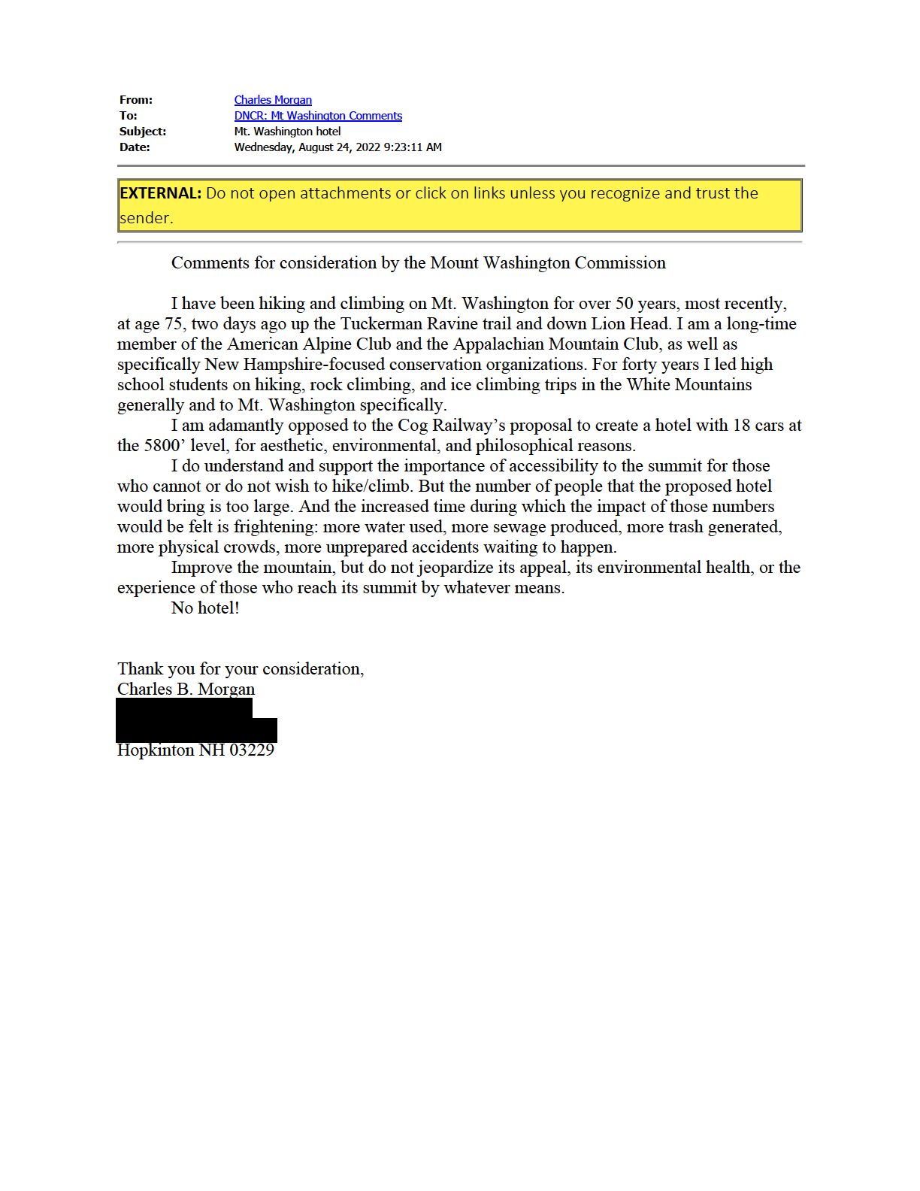
From:
To: Subject: Date:
Save Forest Lake
DNCR: Mt Washington Comments
Mt Washington Master Plan Comments Monday, August 29, 2022 8:52:13 AM
Good Morning Mt. Washington Commission Members:
I am writing to express my strong opposition to the proposed "Lizzie Station" development project. In light of sharing that opinion, I would like to request that the MWC conduct a thorough and independent Environmental and Climate Assessment (E&CA) of the Summit Region and the entirety of Mt. Washington, and that there be a complete moratorium on any future expansion, development or construction of any kind on Mt Washington, until the completion of the
E&C Assessment and the subsequent Master Plan. I know my opinion will matter little, but I think it appropriate that the July 5, 2022 Draft Master Plan be rejected in its entirety and that no MWC Master Plan be written and approved before a credible Environmental and Climate Assessment has been completed.
I would also like to bring your attention to this recent news story:
Canadian hiker dies on Mount Washington
Staff report
Aug 25, 2022
A Canadian man died after he collapsed on Mount Washington on Thursday afternoon.
A 46-year-old man from Quebec had been hiking with his adult son, when he collapsed at the summit of Mount Washington on Thursday, according to a news release from the New Hampshire Department of Fish and Game.
The man and his son were at the Lake of the Clouds hut when the man said he felt short of breath, but they decided to slowly climb to the top of the mountain. Just a few steps from the summit parking lot, the man fell.
Bystanders, including two nurses and a doctor who happened to be on the mountain, performed CPR until state park officials drove the man down the Mount Washington Auto Road to an ambulance.
The man was pronounced dead, according to the Department of Fish and Game.
https://www.unionleader.com/news/health/canadian-hiker-dies-on-mount-
washington/article_8b5c1d47-83c7-548b-ad41-61e3fae69bcb.html?block_id=849467
This begs the question, relative to the proposed Lizzie's Station sleeper car motel project: What kind of emergency services are available should there be a medical emergency in the middle of the evening for a motel guest? Who is liable? Who bears the expense? How much of a time delay would there be in the case of such an emergency, compared to another one, let's say at the Omni Mt Wash? If an emergency crew member is injured in response to a call atop the summit, who bears the liability? Will the sleeper cars be ADA compliant? It seems the Cog itself may not be fully ADA compliant. All questions that need to be answered relative to this irresponsible, dangerous and destructive vanity project that does not serve the public's interest. Thus, any variance requests for this project should rightfully be denied since it cannot meet the standard for variance approval.
Thank You!
Jon Swan
Dalton, NH 03598
Founder, Save Forest Lake Founder, Friends of Mt. Washington

From:
To: Subject: Date:
Rebecca More
DNCR: Mt Washington Comments
Mt. Washington Master Plan- Comments Friday, August 12, 2022 10:48:18 AM
Dear Commissioners, Mount Washington Commission,
The Mount Washington Summit Master Plan is a CRUCIAL opportunity to plan for the future of this unique and FRAGILE eco-system.
The current draft Master Plan suggests a variety of competing goals, including capital improvements, protecting sensitive vegetation, enhancing visitor services, and furthering weather and science work conducted at the summit. I strongly urge the Commission to plan for activities that safeguard Mt. Washington’s critical and endangered ecological role in the northeastern alpine zone and its iconic place in the historic and scientific fabric of our region.
For example, the proposal to put an overnight facility for visitors on the summit will NOT safeguard Mt. Washington's fragile eco-system for the long-term future, nor will it preserve the site for scientific and meteorological research and record-keeping. There is no public benefit that would justify such degradation of the summit.
The Commission should carefully consider the carrying capacity of the summit and plan for facilities that accommodate an appropriate number of DAY-TIME ONLY visitors. Encouraging any significant growth in the number of visitors would place an undue burden on the unique alpine ecology of this site, where sensitive plant species have already been significantly impacted by heavy use. In fact, LIMITS should be considered as at other sensitive environmental sites.
The Commission must plan for improving the physical accessibility of summit facilities and the visitor experience should be enhanced for all persons when considering any user fee proposals for future access.
The summit improvements should be informed by a comprehensive set of environmental studies well-BEFORE any consideration of proposed changes to understand potential impacts. A summit assessment should incorporate these environmental studies, to Avoid any potential impacts on Mt Washington’s alpine ecology. Once the summit is degraded, it will not be possible to rectify, so "mitigation" is not relevant in this instance.
The Master Plan must seek to manage a sustainable footprint on Mount Washington that includes achieving net zero emissions and minimizing waste, noise and light pollution, and scenic impacts of current and future operations.
Finally, the Master Plan outlines additional studies, site plans, and operational plans that will need to be developed. These plans and their implementation should be done in close coordination with the United States Forest Service and other stakeholders to ensure the greatest degree of planning across a larger, integrated landscape.
Regards, Rebecca More
Lancaster, NH 03584

From:
To: Subject: Date:
Alan Bunker
DNCR: Mt Washington Comments
Mt. Washington Master Plan Public Input Wednesday, August 24, 2022 3:55:48 AM
Dear Mt. Washington Commissioners:
I was born and raised in North Conway. I have also lived most of my adult life in or around the Mt. Washington Valley. My wife and 3 kids currently live in Tamworth. My wife and I have been here for 27 years. I am an avid hiker, having done all the NH 48 4K footers in the warmer months. I have done 30 of the 48 in the winter. I am 60 years young.
Pertinent feedback: I have seen use of Mount Washington grow over the years. It is something that concerns me. It is a finite resource. It seems fair that it is enjoyed by hikers and sightseers alike, whether they come up by the Cog, by Coach, or by driving themselves.
However, I believe that the summit of Washington during the summer months, is overrun with foot traffic. I don't have statistics. I am going according to how it feels. There are too many people vying to take pictures at the true summit.(You have to wait in line to even touch the summit.) Too many people waiting to get food inside. Too many people talking outside. Too much commotion going on. It's too busy.
It's not a question of getting better septic and water supply, or a bigger building or buildings. We are intruding on the mountain enough already.
The hiking community has already taken a step, in the past, to reduce hiker traffic on the "Rock Pile". Years ago, the 4,000 footer club was conceived of and publicized. "The New Hampshire 4,000-footer list was created as a way for hikers to explore new areas of the White Mountains."
So, hikers have been aware for many years that that the mountain has been subject to overuse.
Therefore, I am against any expansion of the summit buildings for visitors. (in general)
And, I will also take this opportunity to say that we must not allow any lodging establishment to be built on the side of the mountain, no matter where they wish to locate it. It should not be built no matter the description, no matter the size, no matter whether it is described as appropriate for the surroundings or not. As I said before, we have already intruded enough/too much on Mount Washington.
NO MORE EXPANSION on Mount Washington, please! No bigger buildings, No higher visitor capacity. No motel/hotel/lodging establishments of any kind allowed on the mountain, in any location, no matter the description.
Thank you for listening.
Respectfully, Alan D. Bunker
South Tamworth, NH 03883

From:
To: Subject: Date:
walter north
DNCR: Mt Washington Comments
Mt. Washington Master Plan
Friday, August 12, 2022 10:38:37 AM
Dear Commissioners, Mount Washington Commission,
Dear Commissioners,
(Please disregard an earlier message which was sent as a tech error.)
I want to thank you for undertaking such a comprehensive and thorough review of conditions on Mt. Washington Your consideration of measures to ensure that this incredibly important natural resource is managed appropriately going forward is a very good thing.
The complex dimensions of the problem set you face are magnified by the ongoing consequences of climate change, the pressure for increased human access to an extremely fragile ecosystem, legacy human engineered damage, research priorites and economic interests. Those aspects seem to be wooven into the current draft but not always with the greatest clarity about metrics for assessing some of the tradeoffs that arise or stating goals (ie. tolerable numbers of visitors via the three major access channels, a management structure for controlling that number which ensures that not just the wealthy can access the summit, sanitary standards for waste management, a net zero carbon foot print, outlining existing and planned ecological systems monitoring and restoration efforts/mitigation, etc).
Ideally, 'do no harm' would be the standard across the board but that may be impossible to achieve. Nonetheless, a least harm strategy with mitigation is doable and worth pursuing. I hope more specificity around costs (financial and ecological) and possible cures/fixes of such a strategy can be more robustly demonstrated in your final product.
As is clearly reflected in your draft, Mt. Washington is an amazing place and an extraordinarily special ecological niche located in our region. Your committment to protecting that treasure is much appreciated.
Thank you. Walter North
Regards, walter north
Orleans, MA 02653

From:
To: Subject: Date:
Hello,
Tom Sawyer
DNCR: Mt Washington Comments
Mt Washington Master Plan & Resources - Our COMMENTS Tuesday, August 30, 2022 1:45:12 PM
We are residents of Bartlett, NH and would like to voice our opinion on the Mt Washington Master Plan. First of all we applaud all those who are managing and participating in the endeavor regardless of their views. This process will allow us to proceed in an orderly and logical fashion while listening to various stakeholders.
We feel that the #1 priority should be the preservation of the unique environment offered by Mt Washington and the Presidential Range for the enjoyment of future generations. We are in our 70’s and have spent years hiking and enjoying the alpine flora and the beauty of these mountains. Tom has participated in the annual Mt Washington road race for several years in the 1980’s and we have both spent the night in the Weather Observatory as guests. Our time is coming to an end but we would like future generations to enjoy what we been fortunate to experience. We realize that many people do not have the mental or physical capabilities to hike the Presidentials and witness their wonders. Therefore we see the cog railway and auto road as solutions that allow visitors to experience the mountain with some of the worse weather on the planet and to access areas where rare arctic flowers and butterflies can be seen and appreciated.
However, with this access comes a responsibility to limit encroachment by civilization so that we will not destroy what we cherish. The summit already has the Sherman Adams building providing amenities to visitors and housing the all important weather observatory that will help us to understand and control climate change. The historic Tip-Top house offers visitors a look into the past and the communication buildings exist up there as well to facilitate today’s world of communications. That is enough!
With the recent COVID pandemic, increased pressure has been put on the trails and the summit as visitors choose safer outdoor activities. Therefore we are opposed to any further development on the mountain in order to preserve the environment we all treasure.
Needless to say, there should be small changes periodically to insure safety and aid in the long term conservation effort. However, we oppose changes for generating monetary profit for a few wealthy stakeholders at the expense of the fragile environment. Also the proposal now being contemplated will only benefit those with the financial means to pay for those amenities. Surely this proposal is a very bad, short-sighted plan. Ultimately that short sightedness will destroy much that we hold dear.
Preserve and Protect the Treasures that Mount Washington Offers for All to Enjoy Now and Into the Future.

Tom and Diane Sawyer
North Conway, NH

From:
To: Subject: Date:
Maryann Kotowski
DNCR: Mt Washington Comments
Mt Washington plan -
Friday, August 26, 2022 11:01:39 AM

Please NO ! Preserve and protect what is left of our unique and precious spaces. There is already a road a parking lot and a gift shop!! What next? A carousel and a Ferris wheel? Stop before it’s too late - no 18 hotel rooms. Limit access and charge a fee if you feel the need to profit - but leave it as wild a place as you possibly can. Submitted respectfully and responsibility- Maryann Kotowski. . Thetford Center VT. 05075.

From:
To: Subject: Date:
melodiebelle1
DNCR: Mt Washington Comments
Mt. Washington project proposal Monday, August 22, 2022 8:38:29 AM
I have read about the proposal for the summit plan by the Mt. Washington Railway Company to park more than a dozen sleeper cars on a rail siding below the summit, to create a hotel and restaurant. I oppose this project. Instead the Auto Road and the Cog Railway should investigate ways to limit visitors in order to allow long range success of the Mt. Washington experience of nature at its best. N. H. State Parks and the U. S. Forest Service should also find ways to limit the number of hikers and other human associated impacts on the mountain. Do not defile this majestic mountain with unsightly commercialism and consumerism. Certainly there are other ways to raise money for the upkeep of this iconic place. Raise hiking or driving up the mountain fees. I think people would rather pay a little more than see an unsightly hotel and restaurant on the side of the mountain. We want to see the trees and forest and rolling hills. So I say no to this proposal.
Thank you,
Kathy Ballas Concord, NH 03301

From:
To: Subject: Date:
DNCR: Mt Washington Comments
Mt. Washinton Developement
Wednesday, August 24, 2022 11:12:44 AM
How dare the State of New Hampshire think it is GREAT to commercialize such a treasure. Always in the name of money. As you feel it might make this beautiful area more accessible, it will be changed forever. The though of giving away such a treasure is damned despicable!

From:
To: Subject: Date:
Kevin Moynihan
DNCR: Mt Washington Comments
MWC Draft Master Plan and Lizzie Bourne comments. Wednesday, August 31, 2022 3:20:51 PM
I am writing as a resident of Gorham, NH to express my opposition to the adoption of the July 5, 2022 Draft Master Plan that is currently proposed. In order to maintain even the semblance of legitimacy, the MWC must commit to a thorough and independent environmental and climate assessment of the summit, and surrounding alpine areas. Until such a study is commissioned and the results publicly presented, there should be NO expansion, development or construction of any kind on the summit or in its environs. No "Master Plan" should be drafted or considered until this study has been undertaken, and any vacant seats on the commision have been filled. Additionally I would like to voice my opposition to the proposed "Lizzie Bourne Station". This project has no place whatsoever on the edge of a wilderness area in full exposure to some of the worst weather on earth. It is entirely unnecessary and in my view will only contribute to further degradation of visitors' experience of the Presidential Range. It is my opinion that access to the summit should be strictly regulated in order to prioritize the well-being of the Alpine ecosystem. Building a waste pipeline and disrupting the local ecosystem during a 5 year construction project can hardly be considered stewardship. Any such development by the Cog Railway would be far cheaper and much more appropriate to undertake at the Cog Base Station. Thank you for your time and consideration in this matter.
Respectfully, Kevin Moynihan

MWC Master Plan Comments
172 Pembroke Rd | Concord, NH 03301
August 31, 2022
Mount Washington Commission,
I would like to submit written comments (2 pages) on the Draft Master Plan (Draft 4, 7/5/22) prepared by the Mount Washington Commission. I’m a full time resident of Carroll County, New Hampshire.
The summit of Mount Washington is clearly suffering from high visitation that is overwhelming the facilities and impacting the unique flora and natural resources in the alpine zone.
Buildings, Structures, and Impacted Land
- ● I would like to see the current footprint of buildings (and parking lots) kept as is and not increased.
- ● If possible, I would like to see structures such as fuel tanks removed or re-sited so they don’t have a negative visual impact and don’t cause environmental degradation.
- ● Consider moving communication equipment off the summit, thereby rendering the Yankee Building and towers not needed. Other states and areas of the country operate without the need for communication buildings and towers in sensitive mountain areas.
- ● Please remediate areas of the alpine zone that have been affected by development and return them to their natural condition.
- ● I would like to see the operation of the current summit facilities continue without the need for further development in the alpine zone (on or off NH state property).
Food/Beverage Services
Whether they arrive by hiking trail, train, or road, visitors to the summit are there to experience the environment, weather, and views. While it would be expected to provide some food or beverages, the summit doesn’t need a full service kitchen. Please consider moving food production off site for two reasons:
1. Itwillprovidemoreroomthatisclearlyneededforothervisitorservices. 2. Itwillreducethestrainonthewastewaterandotherassociatedsystems.
I realize that members of the commission will consider this a radical change, but it should be considered. Alternative food/beverage ideas:
- ● Have a full service food production facility off the mountain and transport food/beverages to the summit as needed.
- ● Only sell simple non-perishable food (trail mix, bars, etc.) and beverages on the summit, thereby not needing a full service food production facility on or off the summit.
- ● Visitors can experience full service food options off the summit before or after their trip at the Auto Road base, Marshfield Station, and Pinkham Notch.
Light Pollution
As the International Dark-Sky Association (IDA, www.darksky.org) states: The night sky, filled with stars, is celebrated and protected around the world as a shared heritage benefitting all living things. Please make the summit of Mount Washington “dark sky friendly” so that users on and off the mountain can enjoy the relatively dark skies of the White Mountains. I would encourage the summit partners (Auto Road, AMC, The Cog, Obs, USFS) to use dark sky friendly lighting at all of their facilities, whether on or off the summit. The AMC has experience with dark sky friendly lighting and would be a good summit partner to consult about this improvement.
Summit Capacity Limits
Language in the deeds giving summit property to the state of NH may prevent limiting visitors to the land on the summit, but I would like to see summit partners look into limiting visitors, either voluntarily or through guidelines put in place by the Mount Washington Commission. I applaud the commission for including this language in the draft master plan: Recognizing that there will always be a physical limit to the number of people on the Summit at any given time, the Auto Road and the Cog Railway should investigate ways to limit their visitors in order to contribute to the long range success of the Mount Washington experience. Similarly, the AMC, N.H. State Parks, and the U.S. Forest Service should investigate ways to limit the number of hikers or associated impacts.
Thank you for reviewing my comments and taking them into consideration,
Brian Post
Jackson, New Hampshire

From:
To:
Subject: Date: Attachments:
David W. Ricker
DNCR: Mt Washington Comments
No to Lizzie Bourne Station Proposal Friday, August 19, 2022 3:11:34 PM image001.jpg
To whom it may concern,
The last thing we need is more development on the upper reaches of Mt. Washington. Please vote “No” on the Lizzie Station Proposal. You will kill the very thing you wish to profit from.
Dave
David W. Ricker | Director of Enterprise Analytics and Business Systems | Dartmouth College
david.w.ricker@dartmouth.edu | Office: (603) 646-1065 | Mobile: (603) 960-0956 Mailing Address: 4 Currier Place, Suite 201, HB 6209, Hanover, NH 03755

From:
To: Subject: Date:
Christopher Stoner
DNCR: Mt Washington Comments
No to more development on Mt. Washington Tuesday, August 23, 2022 8:41:00 AM
To Whom It May Concern,
I'm writing to express my vehement opposition to the new planned Lizzie's Station project on Mt. Washington. The summit of Mount Washington maintains one of the last vestiges of alpine habitat in the state, habitat that is incredibly susceptible to development and overuse. The Whites are already under-threat from being "over-loved"... please don't exacerbate the problem.
Sincerely,
Chris Stoner Chesterfield, NH

From:
To: Subject: Date:
Wilson, Graham K
DNCR: Mt Washington Comments
Objection to hotel development Wednesday, August 24, 2022 1:52:29 PM
I would have thought that it is obvious that the State of New Hampshire should do everything in its power to protect the beauty of the White Mountains in general, and the iconic Mount Washington in particular.
I am therefore dismayed to read of the proposal to litter the slope of Mount Washington with nine railroad cars. Although there might be a short term economic gain, the long term economic cost of degrading the beauty that attracts visitors to New Hampshire would be considerable. Economic gain or loss is not the only consideration, however. We have a duty of stewardship to future generations. That duty is not met by littering the mountainside with railroad cars.
Graham Wilson
Gilmanton NH 03237

From: To: Subject: Date:
DNCR: Mt Washington Comments
opposed to expansion on summit Wednesday, August 31, 2022 8:25:36 AM
Dear committee,
I am vigorously opposing the increase of traffic on this iconic mountain. know, there are unique species here and people working hard to safeguard them. Even though I no longer hike this peak (due to the crowds) I know that protecting the habitat and the essence of the mountain from the abuse of overuse is important to the well-being of the entire state. If we ruin this mountain further...
Baxter State Forest in Maine was cognizant of this threat decades ago. Limiting tourists has not hurt their economy and has elevated their status.
This is a stupid idea driven by short sighted profit.
Conduct a full, independent, and thorough E & CA of the entire summit and supporting landscape before any update of the so-called Master Plan.
J. Ann Eldridge, member Bradford Conservation Commission

From:
To: Subject: Date:
Carla Muskat
DNCR: Mt Washington Comments
Oppose further development on the summit of Mt. Washington Tuesday, August 23, 2022 7:13:11 PM
To whom it may concern:
I strongly oppose any further development on the summit area of Mount Washington, a national treasure sadly desecrated by the existing summit structures, which, aside from the weather station, exist solely for the benefit of tourists who mostly arrive by car and train. The hardy hikers do not need such a structure. There are plenty of other spots to build yet another hotel/event space/etc. - let’s not add to the indignity of the summit area by sullying this unique resource any further.
I am sorry to hear that Senator Bradley, himself a hiking enthusiast, would not stand against any further development, and urge him to reconsider his position.
Thank you. Sincerely,
Carla Muskat
Center Sandwich, NH

From:
To: Subject: Date:
Eugene Ward
DNCR: Mt Washington Comments
Oppose Lizzie Bourne Station Proposed Development Sunday, August 28, 2022 6:18:59 PM
I oppose the Lizzie Bourne Station proposed development.
The MWC conduct a thorough, independent, Environmental and Climate Assessment (E&CA) of the Summit Region and the entirety of Mt. Washington. There are already too many folks on the trails; this proposed development would add further pressure on this fragile habitat.
There must be a complete moratorium on any future expansion, development or construction of any kind until the completion of the E&C Assessment and the subsequent Master Plan.
Please reject the July 5, 2022 Draft Master Plan in its entirety and demand that no MWC Master Plan be written before a credible Environmental and Climate Assessment has been completed.
Thank you,
Gene Ward Hollis NH

From:
To: Subject: Date:
Sophi Veltrop
DNCR: Mt Washington Comments
Opposing hotel development on Mt. Washington summit Monday, August 15, 2022 5:28:23 PM
Good afternoon,
I write in staunch opposition to the proposed Lizzie Bourne development of the summit of Mt. Washington. With unsustainable visitorship harming sensitive alpine flora, taxing the wastewater system to the point of non-compliance, negatively impacting the breeding habitat of the rare American pitpit, and causing erosion and pollution issues, further development is not the answer. On top of this, alpine tundra is a rare habitat covering just 13 square miles of the United States east of the Mississippi, and is already facing the cruel stressor of human-caused climate change. Does this unique and irreplaceable habitat need yet another challenge to overcome in its battle to survive the sixth mass extinction? No.
Therefore, as a citizen of New England, a hiker of the White Mountains, and a friend to alpine flora and fauna, I insist that the MWC conduct a thorough, independent, Environmental and Climate Assessment of the Summit Region and the entirety of Mt. Washington. I call for a complete moratorium on any future expansion, development or construction of any kind until the completion of the Assessment and the subsequent Master Plan, and a rejection of the July draft master plan.
Thank you for ensuring my comments and concerns are considered by the Mt. Washington Commission.
Sophi Veltrop

From:
To: Subject: Date:
Spencer MacWilliams
DNCR: Mt Washington Comments
Opposition
Monday, August 22, 2022 12:40:16 PM
Please accept this letter as my official request a hotel is not built on Washington. The mountain has plenty of accessibility to both casual site seers, mountaineers, and everyone in between. The mountain does not need to be more crowded or loud.
Respectfully,
Spencer MacWilliams

From:
To: Subject: Date:
Hackmann, Kent
DNCR: Mt Washington Comments
Opposition to Lizzie Station Project Wednesday, August 17, 2022 10:04:45 AM
Dear Commissioners,
I write to express my opposition to the proposed Lizzie Station Project on Mt. Washington.
I am 85 and a vet. Having viewed Mt. Washington from the hotel at Bretton Woods, my wife and I took guests up to the top on the Cog Railway. It was an experience of a lifetime, viewing the changing vegetation, especially the largest and most significant tract of alpine tundra east of the Mississippi.
In my view, the project will endanger the summit’s “unique flora and other natural resources” as protected by RSA 227-B:6.
While the developers may pledge to preserve the unique natural features, I find it hard to believe that will happen. The proposed Lizzie Station Project will be a major blemish on the face of NH’s most famous mountain. Once in place, it cannot easily be removed.
My prayer is that you will reject the proposed project. Respectfully,
Kent Hackmann
Andover, NH 03216

From:
To: Subject: Date:
Pam
DNCR: Mt Washington Comments
Opposition to parked railway cars Sunday, August 28, 2022 8:54:35 AM
We are writing oppose the new parked railway cars to create a seasonal hotel and restaurant near the summit of Mt. Washington. My family and I have hiked up the mountain, driven up many time and rode the Cog Railway several times. Each time we find this area spectacular and untroubled with a breath taking look every time. We do not want to see a huge hotel in our sites. What about the alpine gardens or any other ecological area that might be destroyed. If you are trying to limit visitors on the summit, why are you considering this project? I don’t think you are looking to the future of this area. Please keep it the way it is.
Gordon Jackson Pamela Jackson Jennifer Jackson-Baro Andrew Baro

From:
To: Subject: Date:
Jonathan Chaffee
DNCR: Mt Washington Comments
Oppossing the proposed Lizzie Bourne Station on Mt. Washington Tuesday, August 16, 2022 12:31:56 PM
Dear Parks and Recreation staff,
I hiked up Mt. Washington yesterday to find throngs at the top, from the auto road, the cog railway and quite a few hikers. Adding “hotel” cars to this mix is insane. Aside from the income to the railway, and the bragging rights to participants, what is the advantage to public recreation? Before you give approval to this purely commercial and not public benefit scheme, please complete an environmental and climate assessment of the summit and the entire mountain. I was appalled, walking out by the Cog Railway, to discover that they are still running two coal burning engines! In this day and age! Some people find it romantic. The pollution from those spreads a stench all across the western slope of the mountain. I’m sure that an assessment would find climate impact from that practice. The uses already deployed need re-assessment for their climate and environmental impact.
Yours, Jonathan Chaffee

Comment on Mt. Washington State Park Draft Master Plan
I support the comments submitted by Jamie Sayen, and his articles published in InDepth NH, which I also submit to the MWC as comments:
https://indepthnh.org/2022/03/23/op-ed-cog-railway-development-proposed-atop-mt-washington/
https://indepthnh.org/2022/08/12/op-ed-cog-railway-proposes-railroad-hotel-near-congested-mt-
washington-summit/
Kris Pastoriza August 22, 2022

Attorney Brooks,
I request that you write a document explaining sovereign immunity as it affects DNCR and the Mount Washington State Park, and post it with the other relevant Mt. Washington State Park Master Plan documents, well before the public hearings on the Master Plan.
If you represent DNCR and cannot write a document which represents the interests of all the Mount Washington Commission partners/members, please state this. The MWC would then, of course, need to find another attorney to write this document, and would need to postpone the public hearings until it has been posted on the site for several weeks.
The document must be detailed and thorough, cite precedent, and explain what the sovereign immunity given to DNCR/Board of Trails in the Gorham trail meant and means, in very specific terms.
Did this sovereign immunity exempt DNCR/BOT from all RSAs governing OHRV siting?
Does sovereign immunity exempt DNCR from all RSAs governing State Parks?
Does sovereign immunity exempt DNCR from all RSAs governing its actions?
Is DNCR automatically given sovereign immunity in a lawsuit or is that a decision of the judge?
Could DNCR/BOT have accepted their responsibility for adhering to the RSAs and refused sovereign immunity in the Gorham lawsuit?
Can DNCR waive sovereign immunity for all but very specific liabilities (RSAs)?
If a lawsuit arose over DNCR’s actions in Mt. Washington State Park, would one expect that DNCR would again be given sovereign immunity, and if so, would they then have no responsibility to adhere to any of the RSAs governing the State Parks? Would they also be immune to other laws; local, state and federal?
What effects does sovereign immunity (potential and actual) for DNCR have on its relationship with the other members of the Mt. Washington Commission? If DNCR supports or recommends certain projects, yet may have no responsibility for the consequences of these projects, how would a lawyer (not representing DNCR) advise MWC members to assess these recommendations?
If DNCR supports or recommends certain projects that are connected to the Auto Road or the Cog, yet potentially has no responsibility for the consequences of these projects, how are these private parties to assess these recommendations?
Since you work for DOJ, which spent approx. $300,000. representing DNCR in the lawsuit brought by the Gorham abutters, and are thus presumably aware of this lawsuit, did you notify the Commission Members of the issue of sovereign immunity for DNCR, and if not, why not?
Did Commissioner Stewart or Phil Bryce notify the Commission Members of DNCR’s sovereign immunity in the Gorham lawsuit and the issues that could arise if DNCR were granted sovereign immunity in any lawsuits over DNCR/private practices or environmental damage, in Mt. Washington State Park? If not, why not?
Inasmuch as New Hampshire politicians are controlled by corporate donors, and DNCR actions are driven by politicians and people appointed by Governor Sununu and thus also influenced/controlled by corporations, which are inherently amoral, can an agency, especially one with sovereign immunity, protect rather than exploit the parks, waters, roads, air and ecosystems for which it is responsible?
Given that DNCR is not acting in accordance with the science on climate change/overshoot/the sixth great extinction, how would sovereign immunity given to them in a lawsuit over their failure to even acknowledge, let alone address, these massive disasters in any meaningful way, affect the outcome of such a lawsuit?
Please include all issues I’ve not listed. Thanks,
Kris Pastoriza Easton, N.H.
June 16, 2022

From:
To: Subject: Date:
Leanne Tigert
DNCR: Mt Washington Comments
Please —-No rail cars on Mt Washington Wednesday, August 24, 2022 2:39:53 PM
Please —- we are already struggling with protecting our natural resources. I am totally opposed to this plan!!!!
Please vote no!!!
Leanne M Tigert,

From:
To: Subject: Date:
Ron Mallie
DNCR: Mt Washington Comments
Proposed Mount Washington Hotel Tuesday, August 30, 2022 12:34:57 PM
To Whom It May Concern:
The guidelines for Mt Washington State Park specify that the mountain and summit should be kept in a natural state while observing the rights of the weather station, auto road, and cog railway. The cog railway is a railway which is not the same as a hotel. A hotel will change Mount Washington both aesthetically, and ecologically -- a hotel is visible whether to those enjoying the summit or to those looking up from the valley. A hotel (on tracks or not) needs water, waste disposal, heat, food, staff, electricity, and parking. These needs will require infrastructure -- either new or existing. If new, then that means new construction. If existing, that means greater load and shorter lifespan for the existing. This is inconsistent with the mandate and not in the interest of New Hampshire. Ninety-nine percent of the visitors to the White Mountains come to experience nature, not development. There are already ample hotels in the area. Why would you significantly diminish an already fragile asset? My belief is that in the long run it will detract more than enhance visits to NH. I will be more motivated to go to better preserved areas such as Maine or the Adirondacks in New York.
Sincerely
Dr. R. Vander Mallie

From:
To: Subject: Date:
Stefan Wisniewski
DNCR: Mt Washington Comments
Protect Mt. Washington
Tuesday, July 19, 2022 5:05:37 PM
Please keep Mt. Washington free from harmful human interference.
Please do it for future generations.
They are much more interested in preserving natural habitat then previous ones.
They will be living in the world of climate change so bad decisions in the matter of preserving nature may have even legal consequences in the future for policymakers.
Please keep Mt Washington free from new development.
Regards
Stefan Wisniewski
Yardley, PA 19067
I'm frequent visitor to Tuckerman's Ravine and wiling to preserve beautiful White Mountains

From:
To: Subject: Date:
Jenn Merredew
DNCR: Mt Washington Comments
Public Comment Re LIzzies Station Proposal Thursday, August 18, 2022 2:52:48 PM
As full time residents of Bethlehem, NH that have line of sight to Mt. Washington from our home, we object to approving the Lizzie Station Proposal and allowing for further development on top of Mt. Washington.
The impact to the surrounding communities and homeowners has not fully been taken into consideration. Although an environmental impact is listed as a fourth priority in the Draft Master Plan, approval should not be given prior to this study being completed by an independent third party. Environmental impact goes beyond the protected flora and fauna that only exists in this region on top of Mt. Washington -- it needs to include the impact that adding light to an area that has dark skies will have on the region.
While researching this issue, it appears as if there are a host of other issues that are not being looked at carefully enough or being overlooked, including outdated permits for water and sewer and outdated development plans that haven't been reviewed in years because of parties that are unwilling to compromise. No business proposal should be allowed to progress without appropriate and updated permits and plans in place.
We ask that the members reviewing this proposal ask themselves how one person (or group) profiting from this expansion should be able to outweigh the greater damage and impact to regional homeowners, visitors, wildlife, and nature. The clear answer is that they should not.
Jenn Merredew Bethlehem, NH 03574

From:
To: Subject: Date:
Richard Miller
DNCR: Mt Washington Comments
Rail plan to build a facility on Mt Washington Monday, August 22, 2022 1:05:58 PM
I've driven up Mt. Washington numerous times. I've run the Mt. Washington Road Race 11 times, mostly before it became so popular. I have skied Tuckerman's Ravine 3 times. We have friends whom I visit in North Conway. Why do I mention all these things? I live in Greenville, close to the MA. border, but I love visiting the North Country. The highlight is seeing Mt. Washington. It's a little bit bigger than Mt. Monadnock or Pack Monadnock!
I would hate to see the vista destroyed by allowing a building to be built near the top of Mt Washington. The only reason for it is so the cog railway can make more profit. Why would we destroy one of the best attractions in NH so they could make more money? Please do not allow this to happen!
Rick Miller Greenville NH 03048

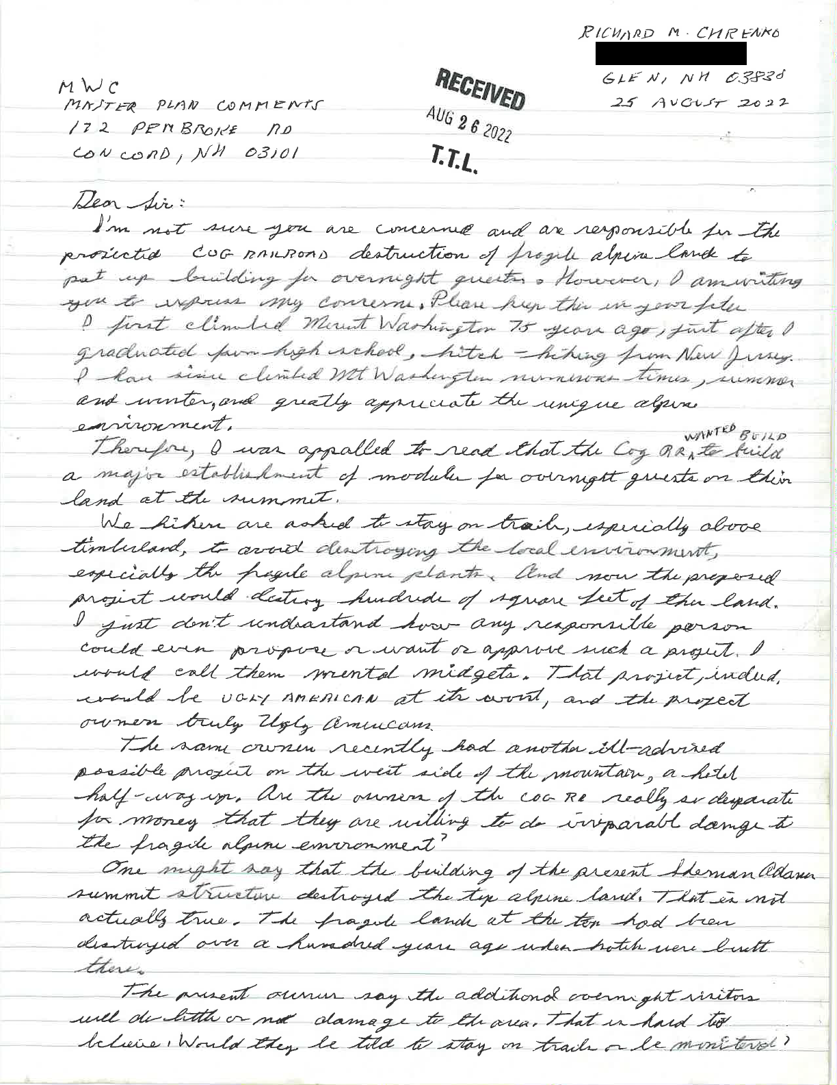

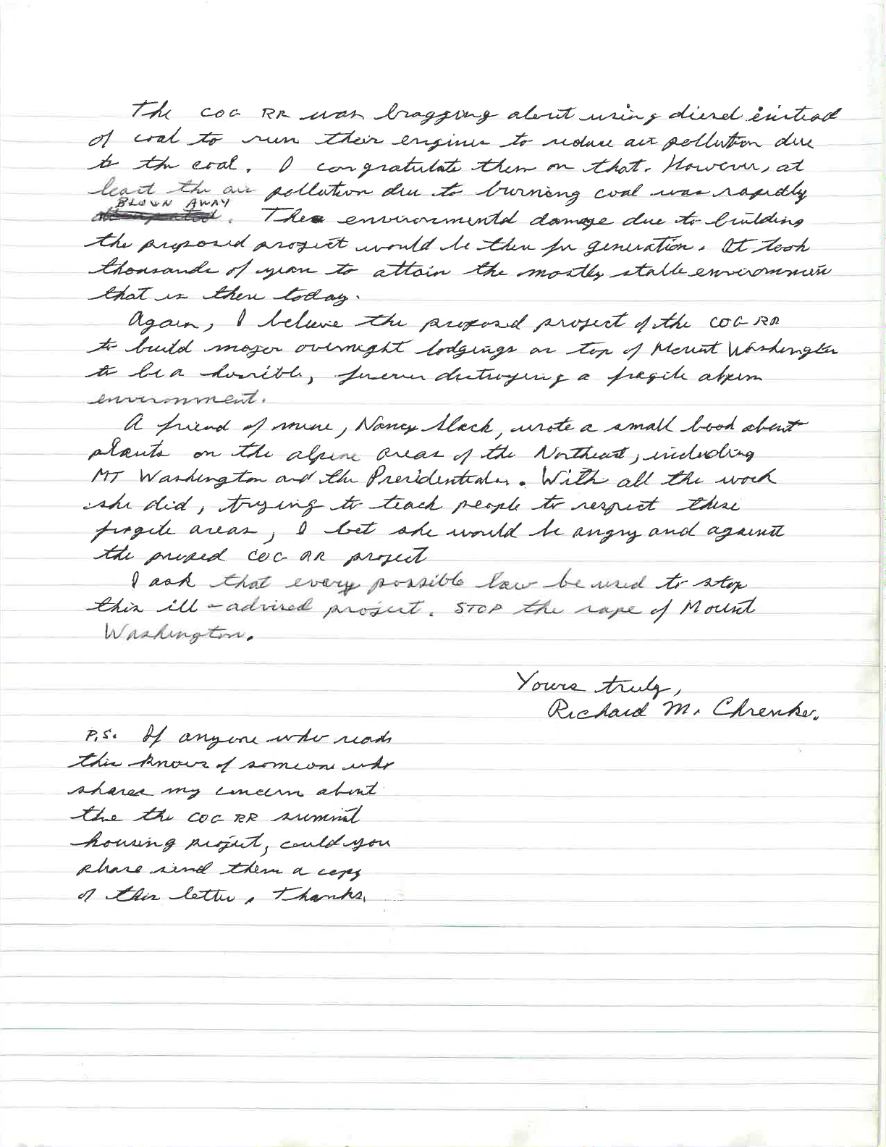

From:
To: Subject: Date:
Eve Goss
DNCR: Mt Washington Comments
Re: $14M Hostelry Project on Mt. Washington Tuesday, August 23, 2022 8:03:08 PM
TO WHOM IT MAY CONCERN:
I am vigorously opposed to any further “development” near the summit of Mt. Washington. I understand that there are plans in the works to “develop” a Hostel, hotel, or other lodging, etc. located somewhere on the slopes of Mt. Washington. This would be in total opposition to the stated purpose of having a White Mountain National Forest! It would totally ruin the concept of wilderness, which was the original purpose of a National Forest. More traffic, noise, trash and pollution must be avoided in any National Forest.
Please consider my comments along with those of my fellow citizens in New Hampshire and elsewhere. Thank you, Eva Goss
Sandwich, NH

From: RICHARD EICHHORN
Sent: Wednesday, August 31, 2022 11:16:32 AM
To: mtwashingtoncomments@dncr.nh.gov <mtwashingtoncomments@dncr.nh.gov> Cc: RICHARD EICHHORN < >; scohen <>
Subject: Cog expansion
Cog Railway expansion on Mt. Washington is a bad idea.
The proposed cog expansion is purely and simply, a hotel compound. Sure, it's composted of portable rail cars, and seasonal, but a hotel none the less. It will require all the infrastructure of a hotel, water, bathrooms, septic, electricity, etc.
Although the cars will be seasonal, many of the infrastructure features that go with it will not be. Imagine the impact that years of construction equipment and activity will have on the natural beauty and local environment. A few extra railway cars sound neat and clean in comparison to the actual aesthetic damage and environmental impact this project will create.
Now imagine the hotel patron, after a night of drinking, that decides to check out the view. What are the chances this person falls, gets hurt, or lost wandering away from the compound.? Now overstretched rescue personal have another rescue mission to deal with. What about the empty glass or beer bottle in their hand. What are the odds it ends up at the bottom of the Ammonoosuc Ravine?
The Cog Railway already seems to give a blind eye to the environmental impact of their activities. If you have ever walked near their property, you would be disgusted on how much scrap coal and other track debris litters the land from their activity.
Miles of track length is bordered on both sides by coal dust, which in no doubt impacts the surrounding environment. Instead of allowing them to spend millions to build more high impact infrastructure on the slopes of one of NH's finest natural features, how about they clean up the environmental disaster they have already caused.
Richard Eichhorn Hopkinton, NH

From:
To: Subject: Date:
Linda Whitworth
DNCR: Mt Washington Comments
Re: Development of Mt. Washington Tuesday, August 23, 2022 6:11:45 PM
I highly disagree with the plans the Cog Railway is making to develop a hotel complex at
the end of their rail on top of the Mtn. It is a bad plan, although I am sure that a lot of people would assure me that it would be done with utmost care about the environment.. It will be bad for the environment and delicate alpine plants growing there. Right now the top of Mt. Washington is like a zoo with people/visitors, some arriving by hiking but most arriving by car, bus or rail.
We do not want to encourage any more than there already is. It needs to be saved for posterity.
Thank you for listening.
Sincerely,
Linda and Derek Marshall Sandwich NH 03227

From:
To:
Cc: Subject: Date:
DNCR: NH Parks
Cheryl Heal
DNCR: Mt Washington Comments
RE: Mout Washington
Monday, August 29, 2022 11:07:40 AM
MtWashingtonComments@dncr nh.gov is where you should direct your thoughts and comments. Kind regards,
N.H. State Parks
nhparks@dncr.nh.gov
-----Original Message-----
From: Cheryl Heal <
Sent: Friday, August 26, 2022 7:10 AM
To: DNCR: NH Parks <nhparks@dred nh.gov> Subject: Mout Washington
EXTERNAL: Do not open attachments or click on links unless you recognize and trust the sender. ________________________________
I read an article in The Conway Daily Sun about a “master plan” for Mt. Washington. It said in the article that the public was welcome to write in comments till the end of August. Before I go on with my thoughts I wanted to make sure that this is where I would be writing to?
Please resond so I can get my voice heard before the deadline.
Thank-you,
Cheryl Heal Sprague

From:
To: Subject: Date:
linda graham
DNCR: Mt Washington Comments
Save Mt Washington
Wednesday, August 17, 2022 9:16:22 AM
Allowing a high end railway hotel and shopping mall is the opposite of the appreciation of the spectacle one hopes will be enjoyed by those going up Mt Washington. This is a bad joke but one that will last far too long. Please do not even consider it. The beauty of the mountain needs to be preserved with some integrity. It is within your power to keep it safe. Linda Graham Concord NH

From: To: Subject: Date:
Good morning,
I'm writing you today to express my disgust, as a NH native, at the blatant disregard for the sensitive ecosystems on Mt. Washington.
Going ahead with any proposals of renovation, expansion and hotel development at this time, with no unbiased scientific reports and research to truly know the environmental costs of such proposals, is reckless, at best, and greedy at worst. How are we to know the impacts of such development without neutral third party scientific study? How are we to know we aren't further degrading this already fragile habitat if you refuse to do the scientific studies needed to create a new, updated Master Plan? A full, comprehensive study of the entire mountain is definitely called for, given that no such thing has been done in well over 2 generations. Who knows what rare species may be discovered? Or how many rare and threatened species use the mountain as their breeding grounds, or home?
To simply forge ahead with plans to scatter human congestion and to allow the Cog to build a hotel is pure Idiocracy! We should be working to protect this delicate ecosystem for generations to come, not exploiting it for every penny until the entire mountain is a trash heap.
The new, July 5th Master Plan needs to be thrown out, and a new one drafted after full feasibility and scientific studies can be conducted and considered. A moratorium on any new development and any major redevelopment or refurbishment should be in acted until such studies are complete. The several years such studies would take are a small price to pay to ensure the entirety of the Mt Washington ecosystem is protected and properly managed, even if such studies show that allowing fewer yearly visitors is warranted.
It's time for us to set greed aside and to protect the things worthy of protection, such as the Crown Jewel of NE that Mt Washington is. Not everything that Can be exploited should be exploited.
Thank you Leah Gage Brookfield NH

From:
To: Subject: Date:
Carol Fleischman
DNCR: Mt Washington Comments
SAVE OUR SNOW: CURTAIL GHG EMISSIONS ON MT WASHINGTON Friday, August 12, 2022 10:46:50 AM
Dear Commissioners, Mount Washington Commission,
It is urgent for everyone to do everything within our power to reduce greenhouse gas emissions.
On Mt Washington, this means banning internal combustion vehicle traffic. Yes, this means that only EV's would be sporting that hokey "This Car Climbed Mt Washington" bumper sticker. Really, no car should be climbing Mt Washington. Maybe an electric jitney could bring guests up and down.
And, the Cog Railway needs to be electrified. Like, now.
In addition, the Commission should carefully consider the carrying capacity of the summit and plan for facilities that accommodate an appropriate number of visitors. Allowing for or encouraging a significant growth in the number of visitors would place an undue burden on the unique alpine ecology of this site, where sensitive plant species have already been significantly impacted by heavy use.
The Commission must plan for improving the physical accessibility of summit facilities and the visitor experience should be enhanced for all persons when considering any user fee proposals for future access.
The summit improvements should be informed by a comprehensive set of environmental studies that must be completed to understand potential impacts. A summit assessment should incorporate these environmental studies, to avoid, minimize and mitigate any potential impacts on Mt Washington’s alpine ecology.
The Master Plan must seek to manage a sustainable footprint on Mount Washington that includes achieving net zero emissions and minimizing waste, noise and light pollution, and scenic impacts of current and future operations.
Finally, the Master Plan outlines additional studies, site plans, and operational plans that will need to be developed. These plans and their implementation should be done in close coordination with the United States Forest Service and other stakeholders to ensure the greatest degree of planning across a larger, integrated landscape.
Regards,
Carol Fleischman
Ardmore, PA 19003

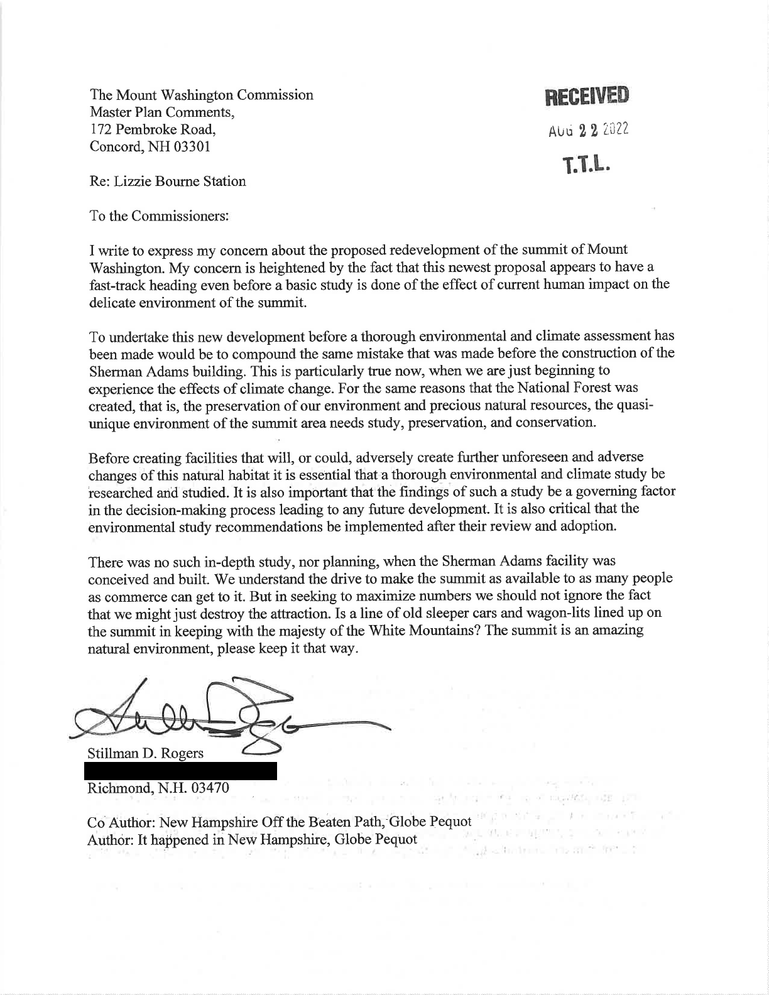
From:
To: Subject: Date:
David Abusamra
DNCR: Mt Washington Comments
The cog new railway plan
Wednesday, August 24, 2022 4:44:55 PM
To whom it may concern,
I am adamantly opposed to ANY further development of the cog railway site, in any manner, shape or form.
David Abusamra Brentwood, NH 03833

From:
To:
Cc: Subject: Date:
Richard Knox
DNCR: Mt Washington Comments
Richard Knox; Jean Knox
Time to reassess and plan to protect Mt. Washington Tuesday, August 23, 2022 10:51:44 AM
Dear Mount Washington Commission members:
We are writing to express our strong belief that now is the time for the Commission (or the New Hampshire Department of Natural and Cultural Resources, which you advise) to authorize a comprehensive, thorough-going and independent assessment of the current and future impact of tourism on Mount Washington.
This assessment must serve as the basis for the development of a master plan for the summit and all the routes to the summit in light of the ecology of this unique place. The master plan should take into account the impact of climate change and how science-based evidence must inform future uses of the mountain.
While this overdue process proceeds, there should be a total moratorium on expansion of existing facilities and the development of new uses, including the proposed “Lizzie’s Station” project. We want to be clear that our position is not based on the “Lizzie” proposal alone; that proposal, however, presents a compelling case for a comprehensive review of the vastly increased pressures on this fragile terrain since the long-outdated Master Plan of 1970.
We have hiked and driven up Mount Washington over the past decades, so we appreciate first- hand what a previous resource it is, and how deserving this mountain is of our best stewardship. This summer we rode the Cog Railway with our 6-year-old grandson. We were struck by how dramatically the pressures on the Washington summit have increased — in parallel with tourist pressures on other national parks, such as Yellowstone and Yosemite.
We are certainly not in favor of closing off public access, but it is clear that thoughtful management in urgently needed. We agree with Commissioner Wemyss’s recent conclusion that the proposed analysis and updated Master Plan “will be essential to the future health and success of Mt. Washington and the Mt. Washington partners.” We strongly urge you and state/county officials to ensure public participation and transparency as this process goes forward.
Not to seize this opportunity to reassess and plan, we believe, would bring shame upon New Hampshire and those with the responsibility of sustainably managing Mt. Washington for our grandchildren and future generations.
Thank you for your consideration of our viewpoint, which is shared by many others.
Richard and Jean Knox Center Sandwich, NH

From:
To: Date:
Charlene Browne
DNCR: Mt Washington Comments
Thursday, August 18, 2022 2:40:32 PM
We oppose the Lizzie Bourne Station proposed development.
We demand that the Mount Washington Commission conduct a thorough, independent Environmental and Climate Assessment of the Summit Region and the entirety of Mt. Washington.
The Master Plan 1970 needs to be appropriately updated since it was written 50 years ago when acid rain and other flora and fauna issues were just being initially understood and environmental impact statements through NEPA were first being adopted by states and I beliveNH did not adopt until a few years later.
In the June 10 master plan meeting, Senator Bradley rejected Wemyss’—and repeated public—calls for an environmental assessment first. The Commission, lacking a quorum, informally adopted the Draft MP it released to the public on July 5.
The July 5,2022 draft was hastily adopted without proper input in a publicized public forum. Until the draft new master plan has had professional and public input we reject the July 5, 2022 Draft Master Plan in its entirety and demand that no MWC Master Plan be written after a credible Environmental and Climate Assessment has been complete . This assessment must include environmental professionals such as ornithologists, botanists , landscape architects, environmental climate scientists. We also demand that the public (residents of the state, state specialists be given the information and have time to respond and supply their input before the master plan is finalized.
Sincerely Charlene Browne Richard Davis
North Conway, NH

From:
To: Subject: Date:
Kate Hesler
DNCR: Mt Washington Comments
Writing in opposition of hotel development on Mt. Washington Monday, August 29, 2022 1:02:07 PM
Good afternoon,
My name is Kate Hesler. I have been lucky enough to grow up in the White Mountains and call it home for the last 21 years. I am an avid hiker and outdoor enthusiast, and I am reaching out in strong opposition to the proposed hotel development ("Lizzie Bourne Station") in the fragile ecosystem of the alpine zone.
We are at a pivotal moment in our history where we should all be reckoning with the challenge of climate change right in front of us. Mount Washington is a one-of-a-kind mountain and important ecosystem in the Eastern United States. Sadly, that ecosystem has already been significantly disrupted by the present-day cog railway, auto road and commercial developments on the summit. Why are we even considering more development on this great mountain in this day and age?
The alpine zone of Mount Washington is one of only two locations in the Eastern US where the rare bird, the American pipit, calls home and breeds in the warmer months. NH Fish and Game lists this bird as a "species of greatest conservation need" due to population numbers already declining.
In addition to wildlife, such as the American pipit, Mount Washington is home to a significant portion of alpine tundra in the Eastern US. For example, there are only 13 square miles of alpine tundra east of the Mississippi River, and Mount Washington is home to the largest portion of that. Alpine tundra is home to a wide diversity of rare plant life found nowhere else. Another strikingly important element that must be prioritized and protected.
Significant construction is required to build this proposed hotel, causing destruction, disruption and waste in and around the site. Mount Washington is one of the most well-known and highly regarded wilderness areas in the Eastern US and it is a major asset to NH tourism and state pride. The State of NH must stand up and protect this mountain from future development and destruction. The mountain and surrounding area are being exploited for its resources and for monetary gain - it has to stop.
Please take a look at this Change.org petition that has already achieved more than 30,000 signatures. 30,000 other people strongly stand in opposition of this
project. https://www.change.org/p/mount-washington-commission-stop-the-cog-railway- again-from-building-a-luxury-hotel-on-mount-washington
We are demanding a thorough and independent ecological and climate-based assessment of the mountain from base to summit before this project moves forward another step. Independent, non-government based scientists must be involved in this process to ensure that the environment is being prioritized over private monetary gain. The project being proposed is huge, but in the long run, it will not drastically increase access or visitors to the mountain, but the construction and the process will drastically affect the fragile ecosystem of Mount Washington. As another reminder, while the Presby's own the Cog Railway and the small buffer of land on either side, the land elsewhere on the mountain is NH public land - owned and utilized by NH residents, not private companies to exploit. Public land is an amazing natural resource across the US that must be protected for citizens and visitors for recreation and wilderness escape.
Thank you for taking the time to read my comments. I urge that you seek knowledge and guidance from independent scientists before making any decisions. I urge you to protect this fragile ecosystem and prioritize the environment over commercial monetary gain. I urge you to reject this project and implement a complete moratorium over future development, expansion or new construction on the mountain.
Thank you, Kate Hesler

Appendix C, FEIS, 2005 Forest Plan, White Mountain National Forest.
Jones, Mike and Liz Willey, eds. Eastern Alpine Guide: Natural History and Conservation of Mountain Tundra East of the Rockies. University Press of New England, 2018.
Ibid.
Ibid.
NH Statutes, Title XIX, Public Recreation, Chapter 227-B, Mount Washington Commission
Appendix C, FEIS, 2005 Forest Plan, White Mountain National Forest.

